Shell Foundation – Final Case Study Document

**Website (OrangeHRM) :** <https://opensource-demo.orangehrmlive.com/web/index.php/auth/login>

**Objective:** To test the concepts of SDLC, Agile, Software Testing, DBMS and CI/CD pipeline.

**Task Instructions**

The below activity must be performed individually.

Follow the below instructions for the OrangeHRM website

**SDLC, Agile and Software Testing**

1. Open Azure DevOps.

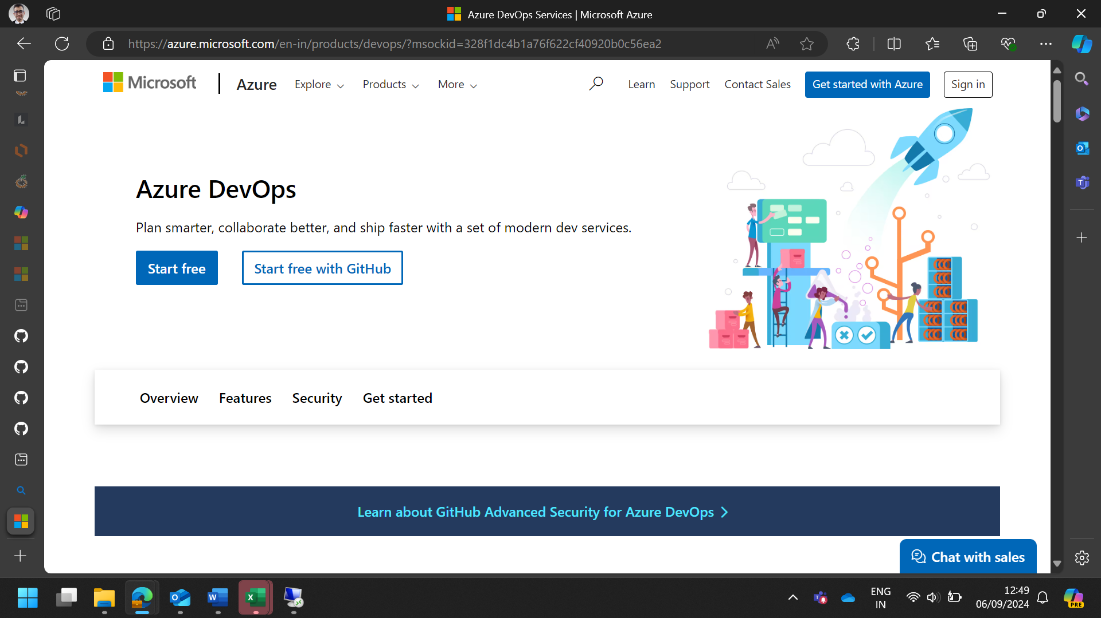

1. Create an Azure Virtual Machine (VM). You need to perform all the tasks within the VM.
2. **Sign in to Azure Portal**:
   * Go to the Azure portal and sign in with your Azure account credentials.

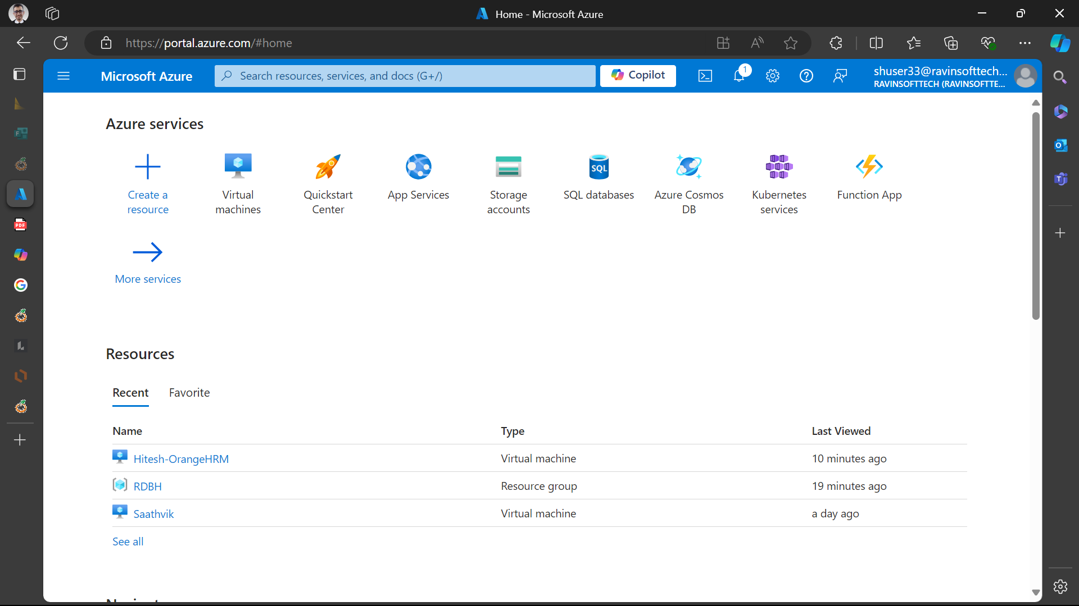

1. **Navigate to Virtual Machines**:
   * In the left-hand menu, select “Virtual machines” or use the search bar at the top to find it.

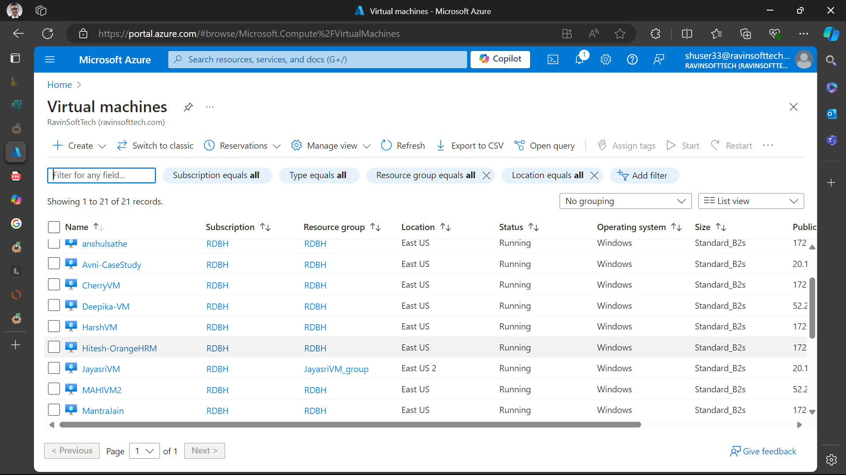

1. **Create a New VM**:
   * Click on the “Create” button and then select “Azure virtual machine”.

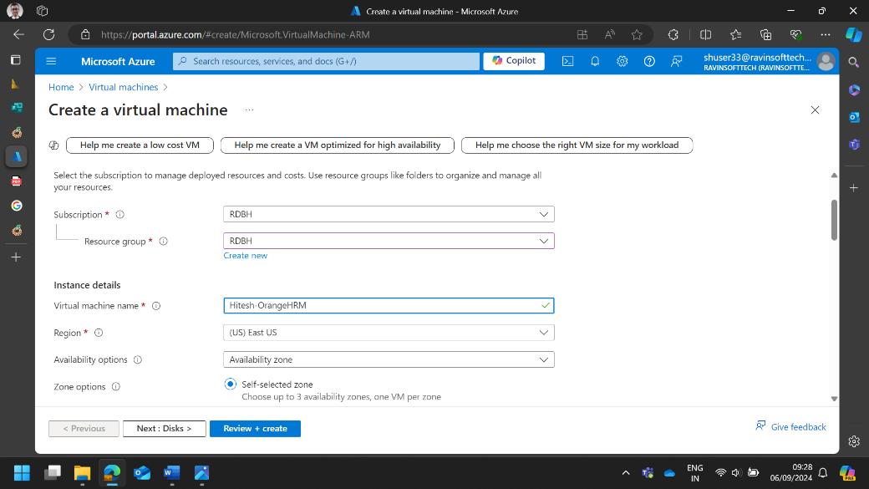

1. **Configure Basic Settings**:
   * **Subscription**: Choose your Azure subscription.
   * **Resource Group**: Select an existing resource group or create a new one.
   * **Virtual Machine Name**: Enter a name for your VM.
   * **Region**: Choose the region where you want to deploy the VM.
   * **Availability Options**: Select availability options if needed.
   * **Image**: Choose the operating system image (e.g., Windows Server, Ubuntu).
   * **Size**: Select the VM size based on your requirements.

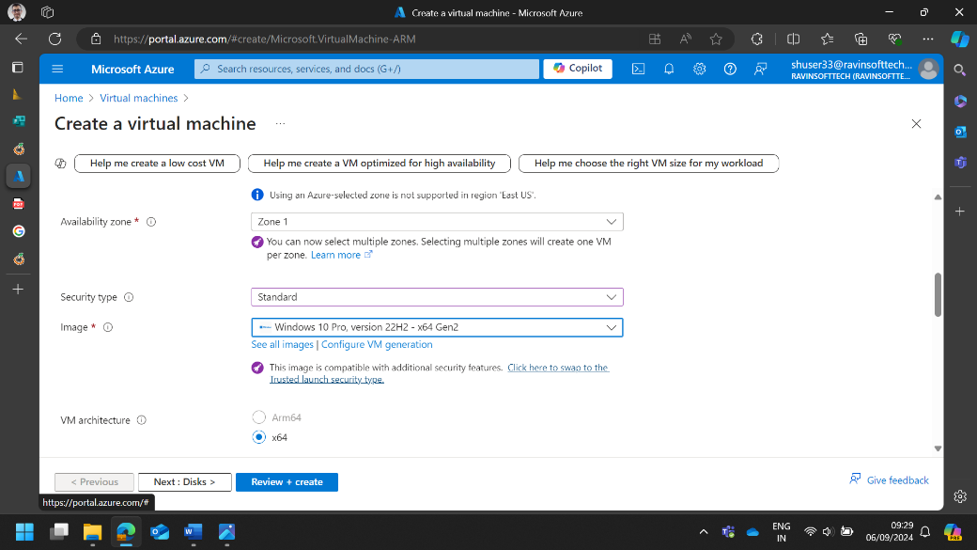

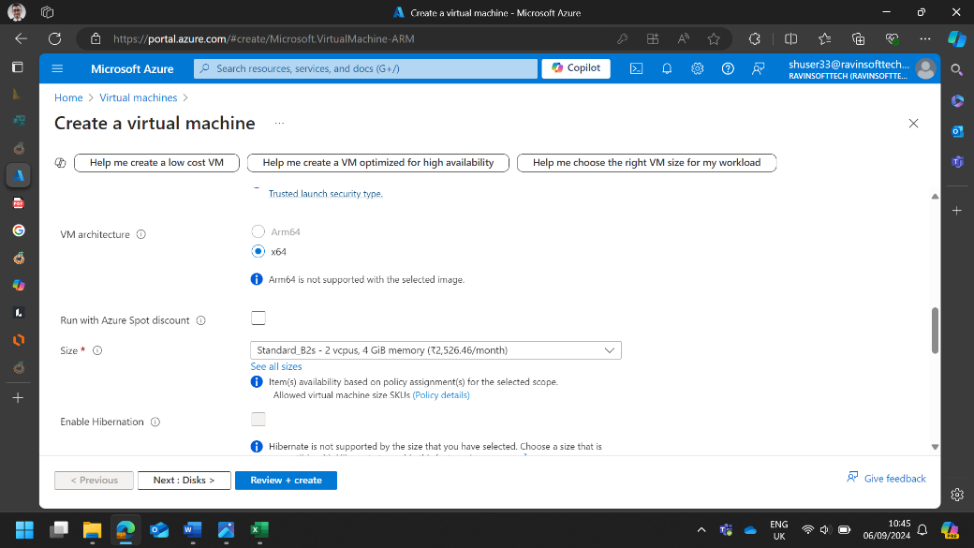

1. **Administrator Account**:
   * **Username**: Enter a username for the VM.
   * **Password**: Create a strong password.

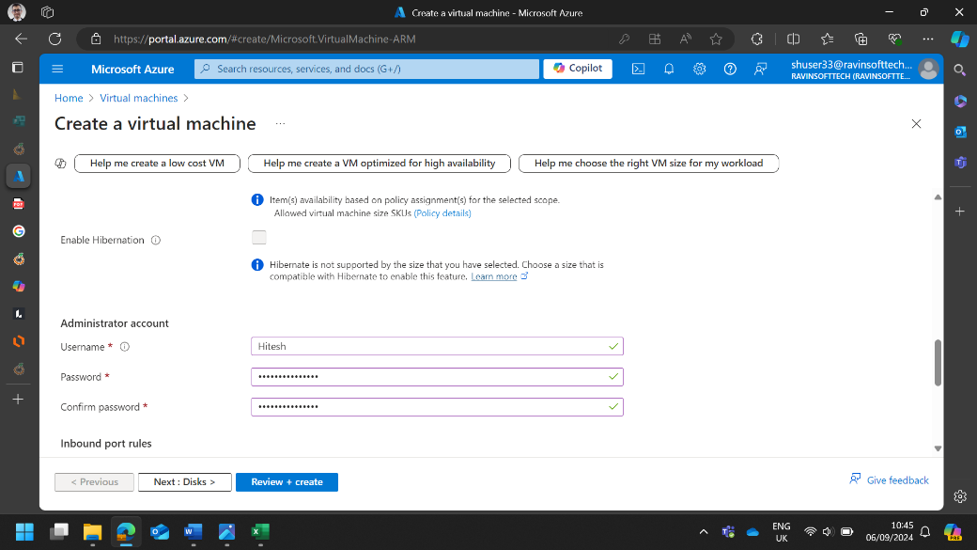

1. **Inbound Port Rules**:
   * Allow necessary ports (e.g., RDP for Windows, SSH for Linux).

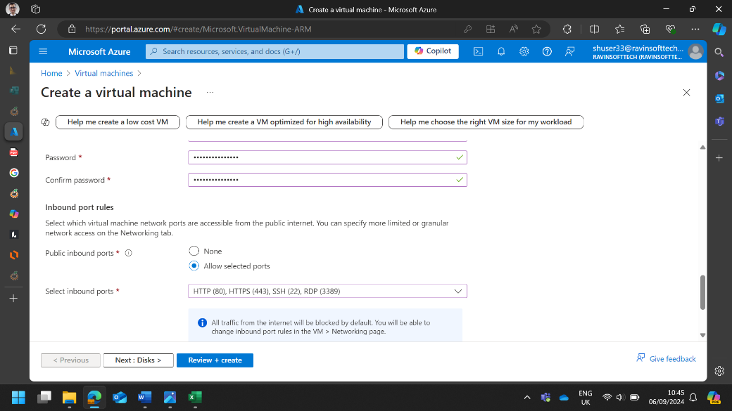

1. **Disks**:
   * Choose the OS disk type (Standard HDD, Premium SSD, etc.).
   * Add any additional data disks if required.

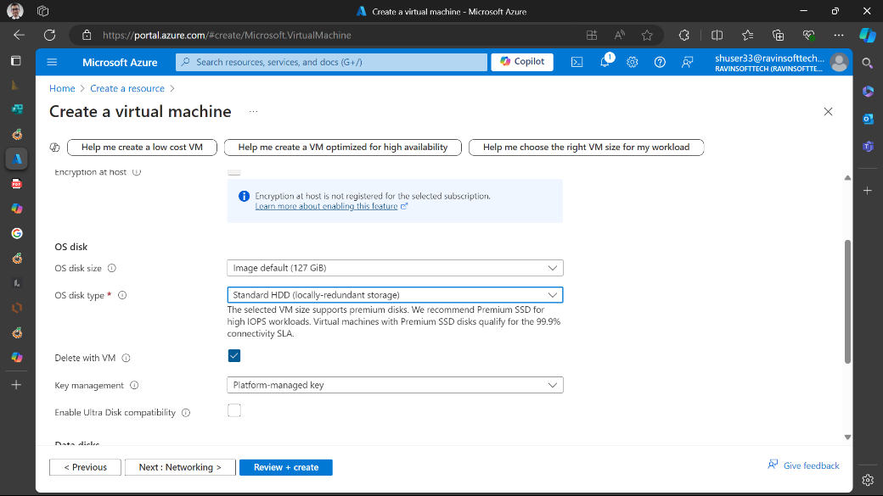

1. **Networking**:
   * Configure the virtual network, subnet, public IP, and network security group settings.

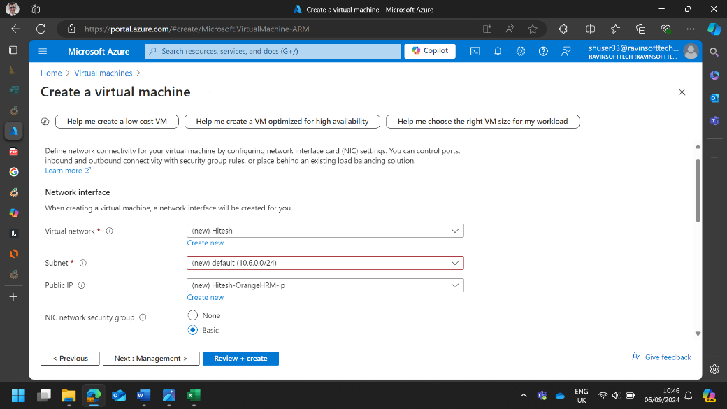

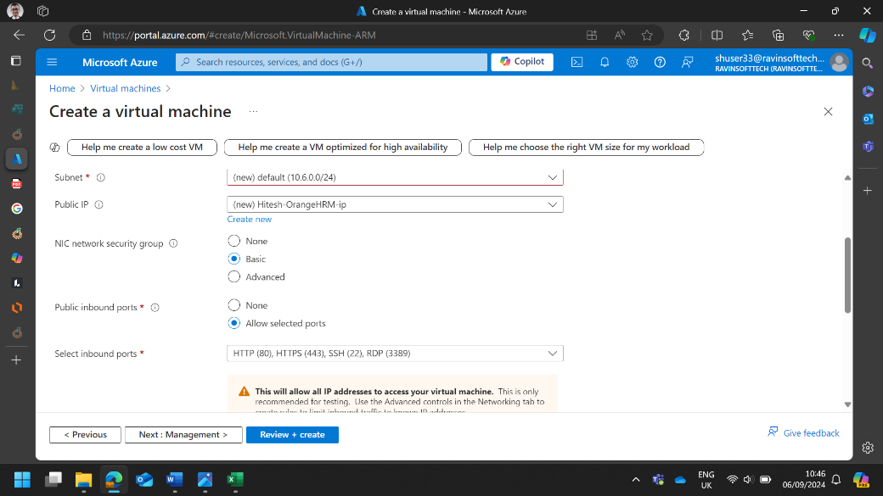

1. **Review + Create**:
   * Review all the settings and click on the “Review + create” button.
   * After validation, click on the “Create” button to start the deployment.

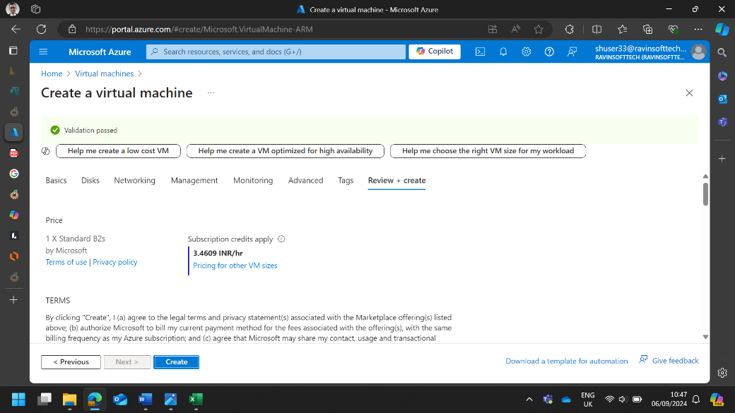

1. **Connect to the VM**:
   * Once the VM is deployed, go to the VM resource page.
   * Click on “Connect” and choose the connection method (RDP for Windows, SSH for Linux).
   * Download the RDP file or use SSH to connect to your VM.

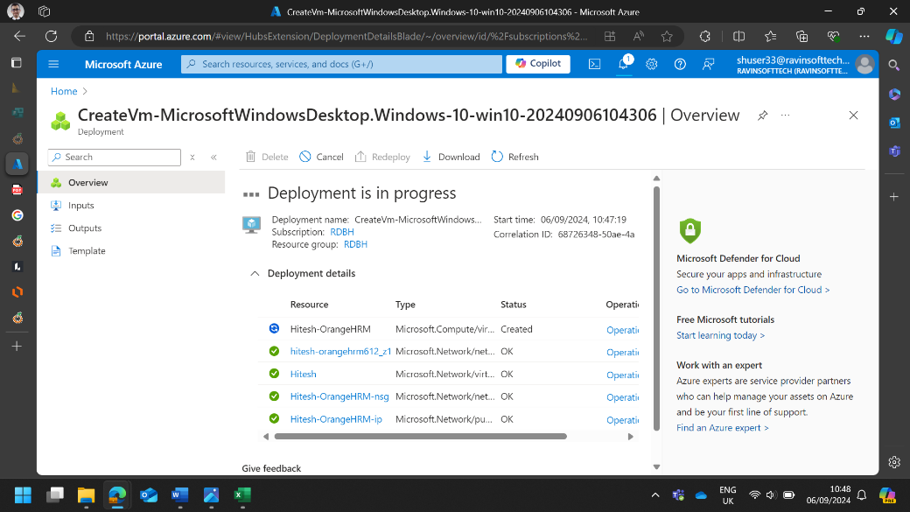

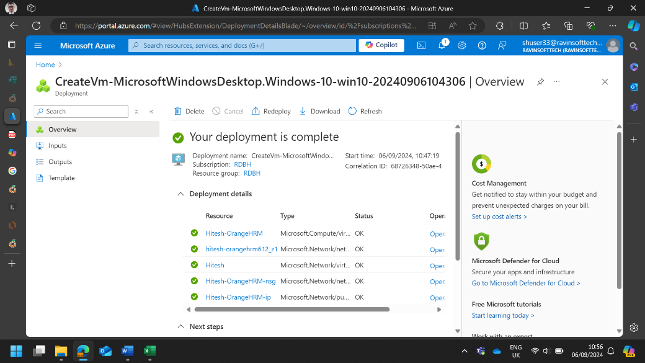 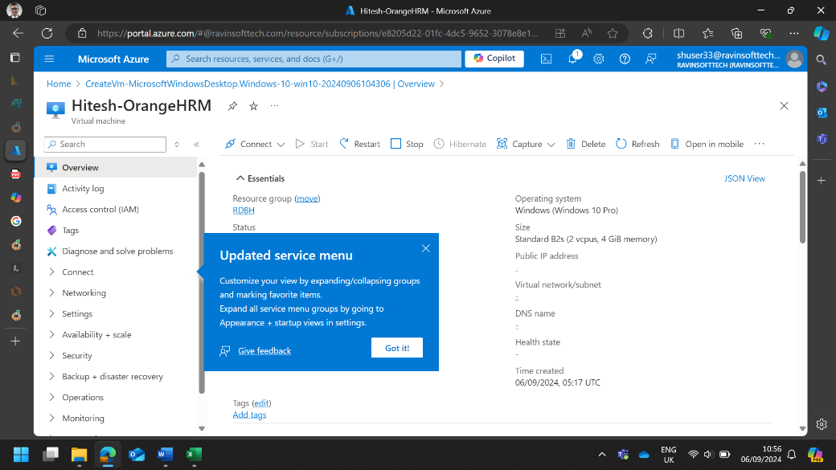 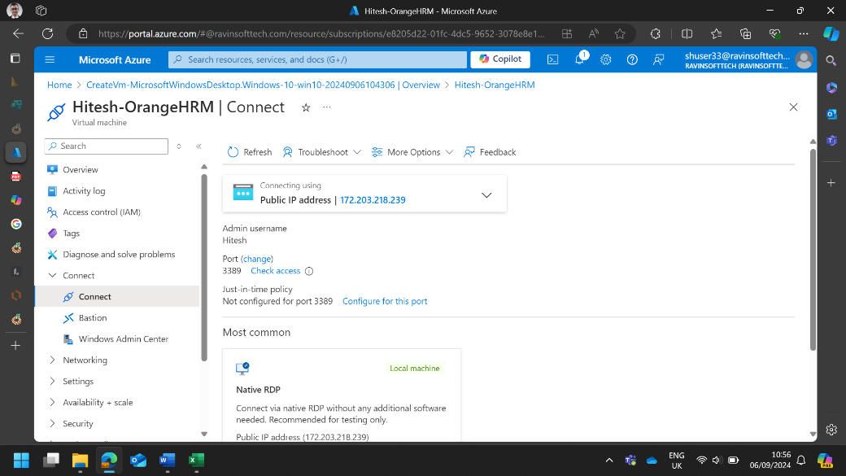 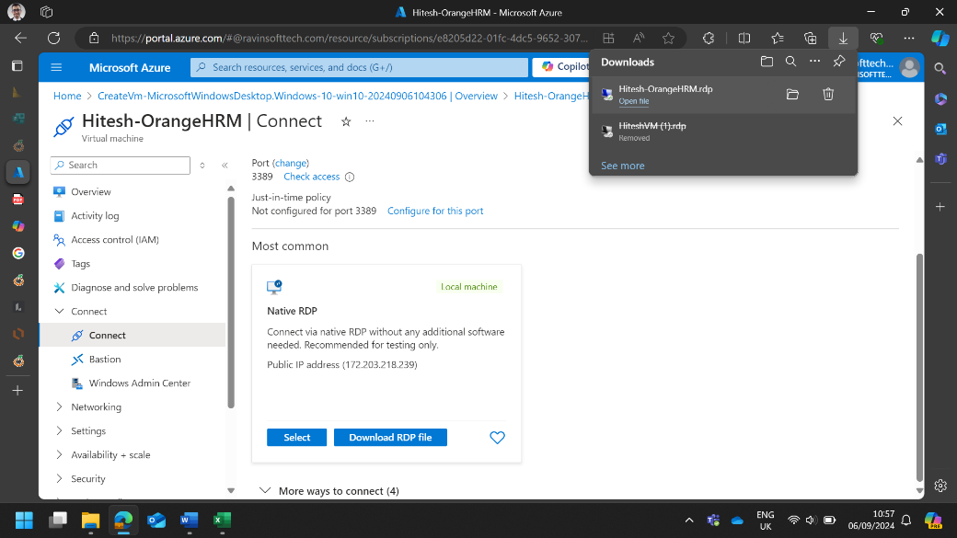 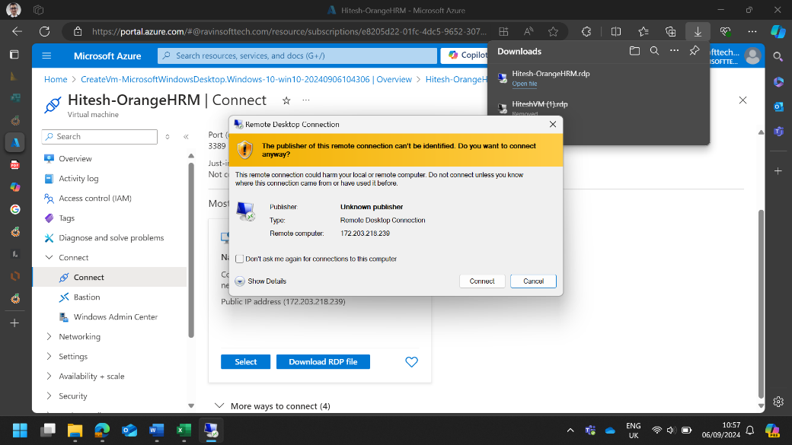 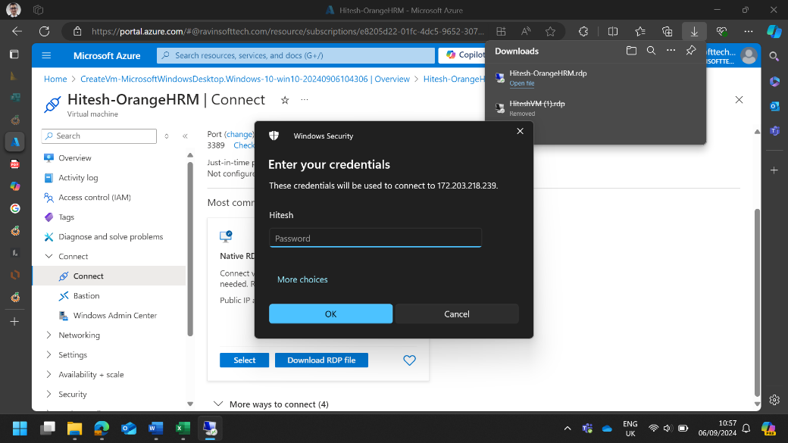 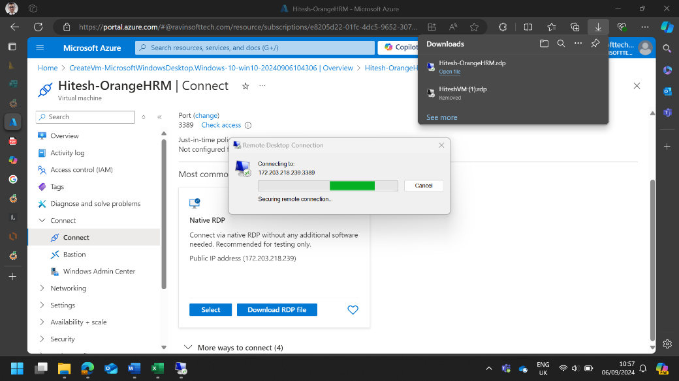 12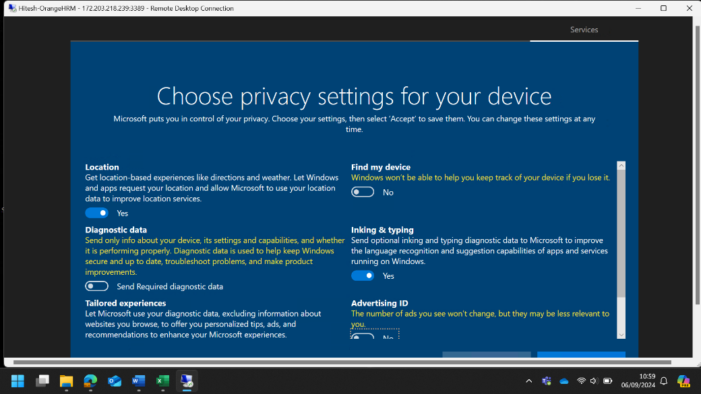 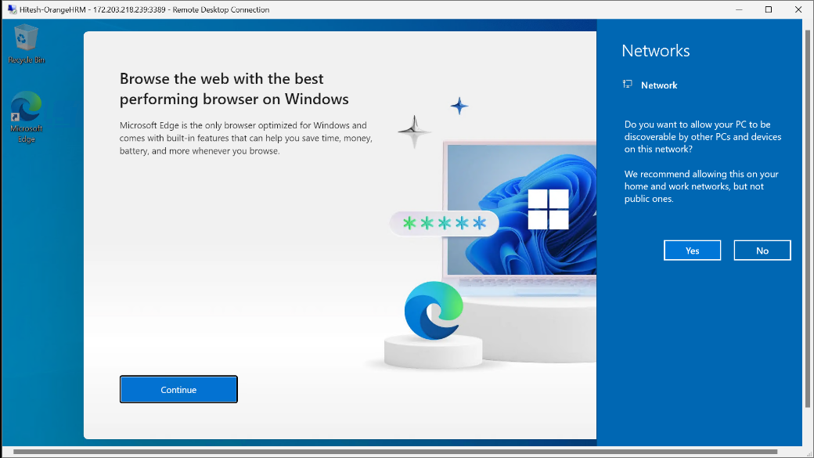

1. Login to the azure DevOps portal and navigate to the project.

|  |
| --- |
| Epic: User Management in OrangeHRM **Epic Description:** As an Admin, I want to efficiently manage user accounts within the OrangeHRM system, including adding new users, editing user details, assigning roles, deactivating accounts, and viewing user activity logs. This will ensure that the system is secure, up-to-date, and that user activities are monitored for compliance.  **Benefit Hypothesis:** By implementing comprehensive user management features, OrangeHRM can enhance the security, accuracy, and efficiency of its HR management processes. Admins will be able to manage user accounts effectively, ensuring that only authorized users have access to the system and that user activities are tracked and monitored.  **Acceptance Criteria:**   * The system should allow Admins to add new users with valid details. * The system should enable Admins to edit existing user details. * The system should allow Admins to assign specific roles to users. * The system should enable Admins to deactivate and reactivate user accounts. * The system should provide Admins with access to user activity logs, including filtering and exporting options. |

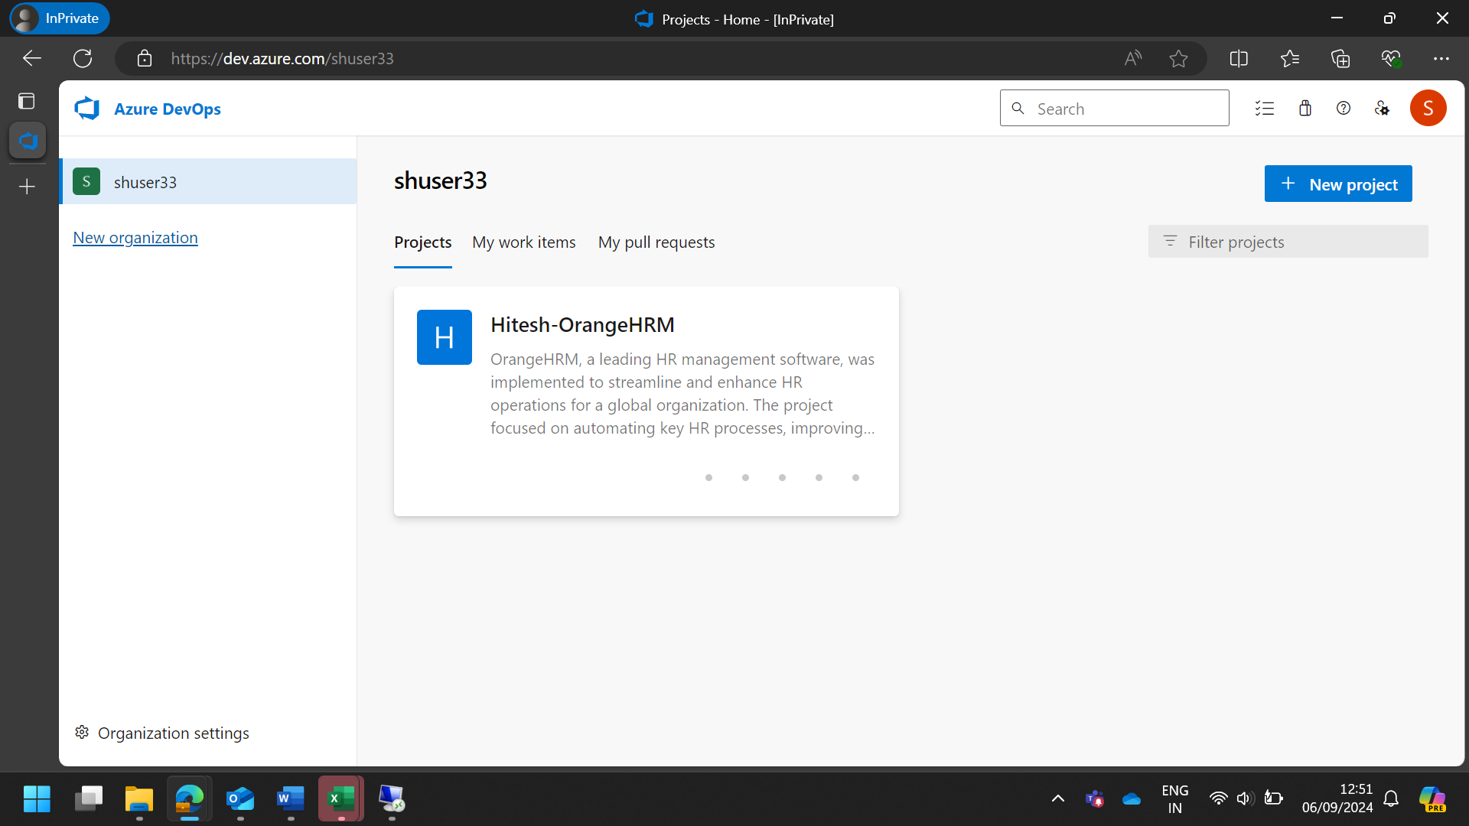

1. Create a New Sprint. Set the Sprint goals and objectives, aligning them with the overall testing strategy for the website.

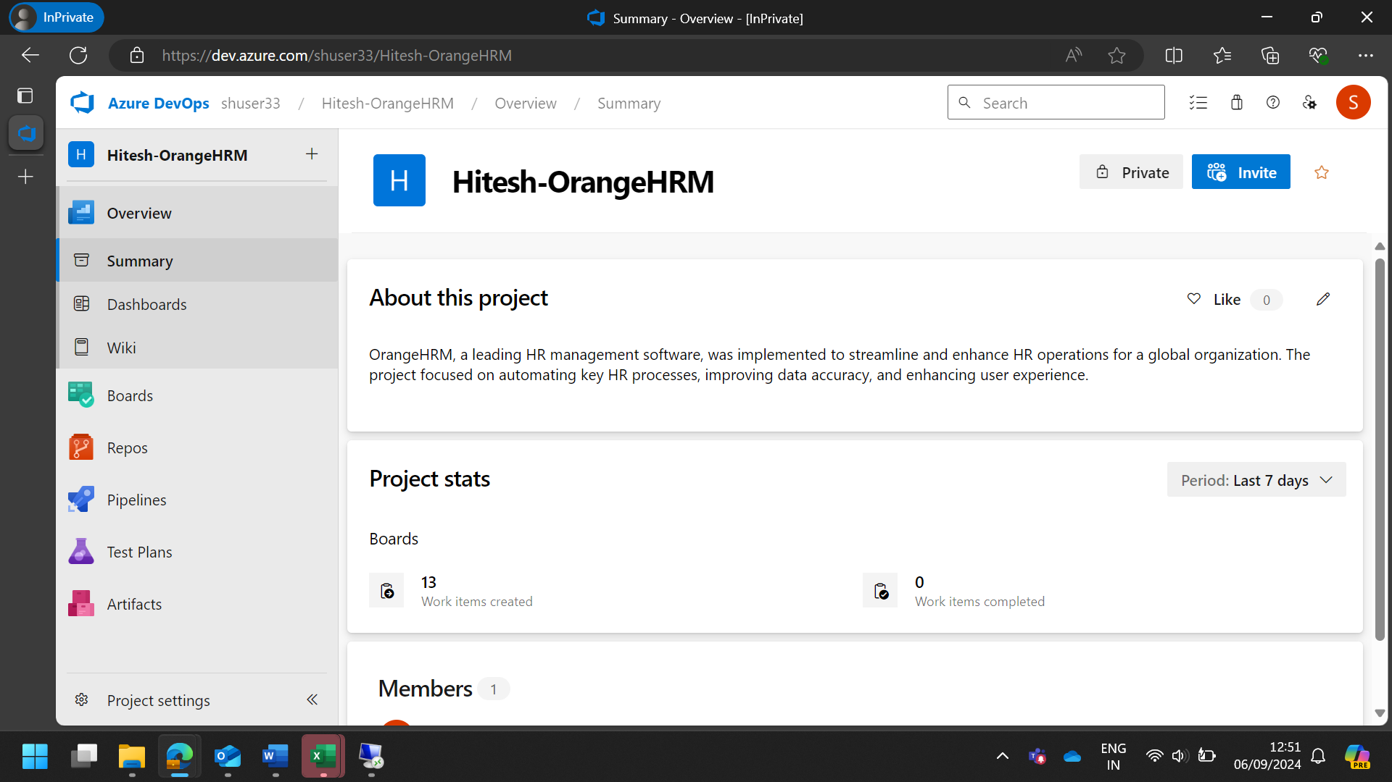

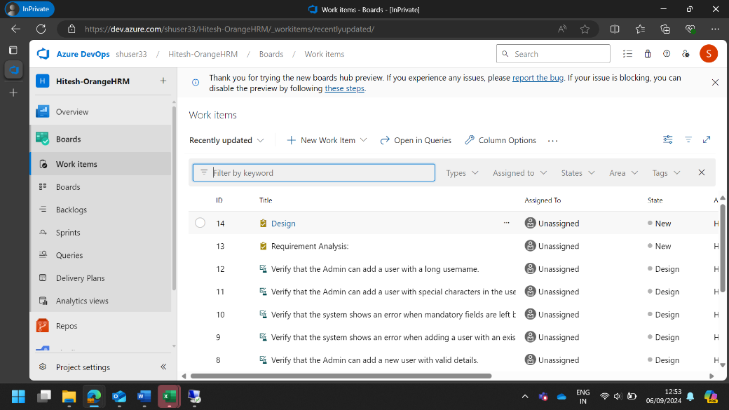

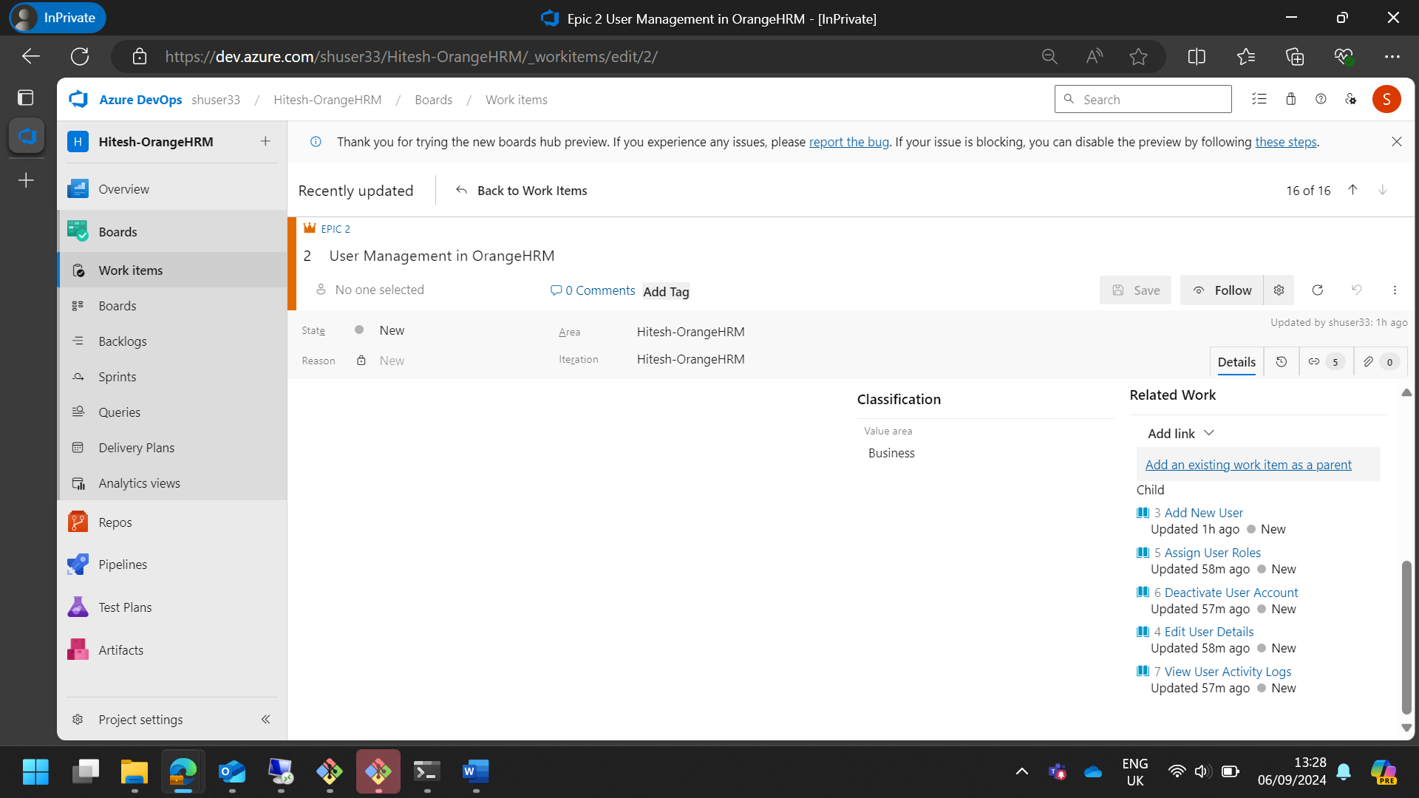

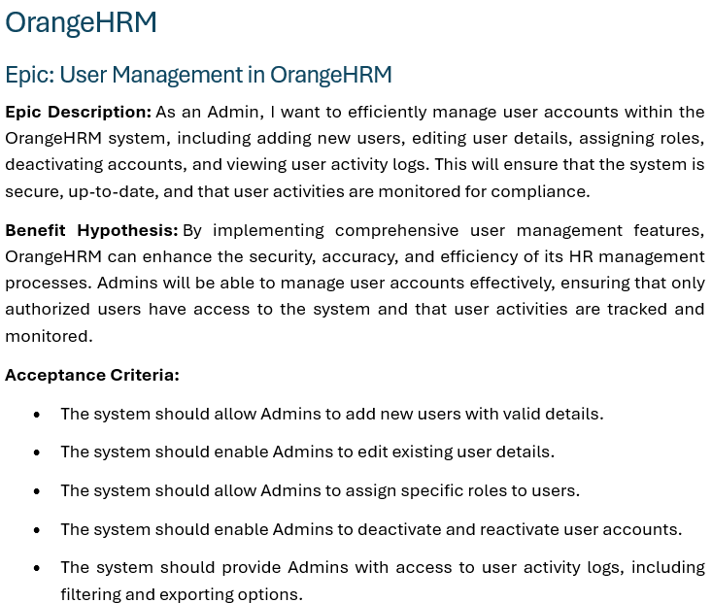

1. Create 5 User Stories in the Sprint for the Sprint Backlog for the given application.

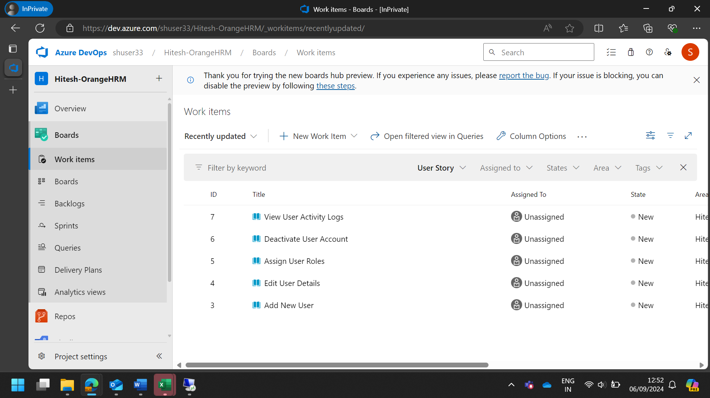

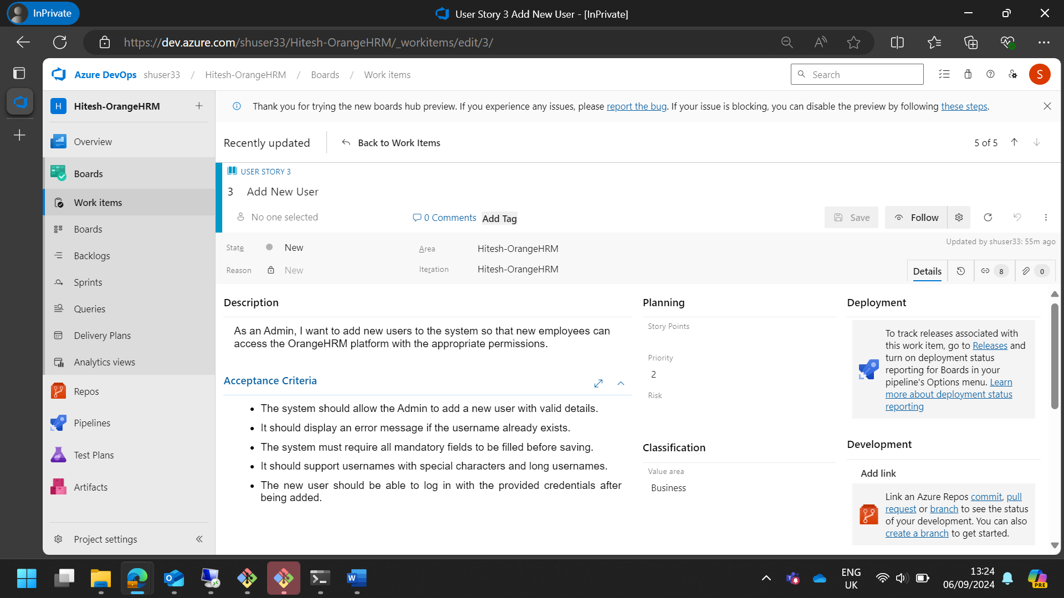

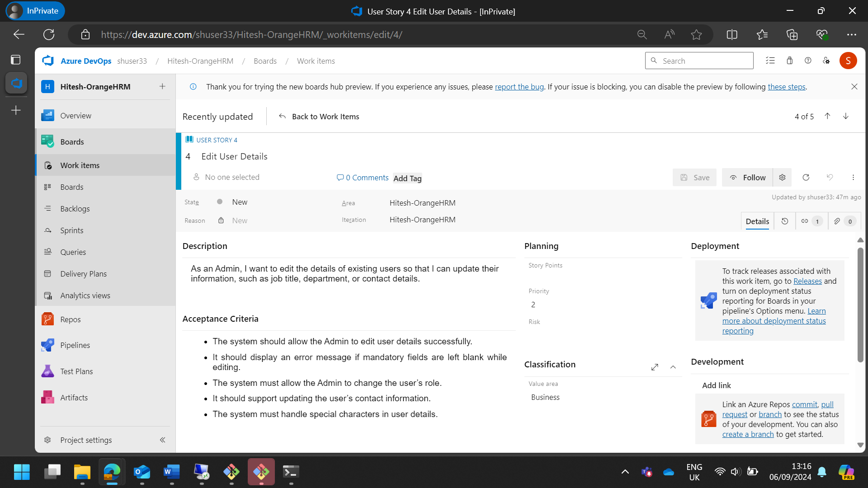

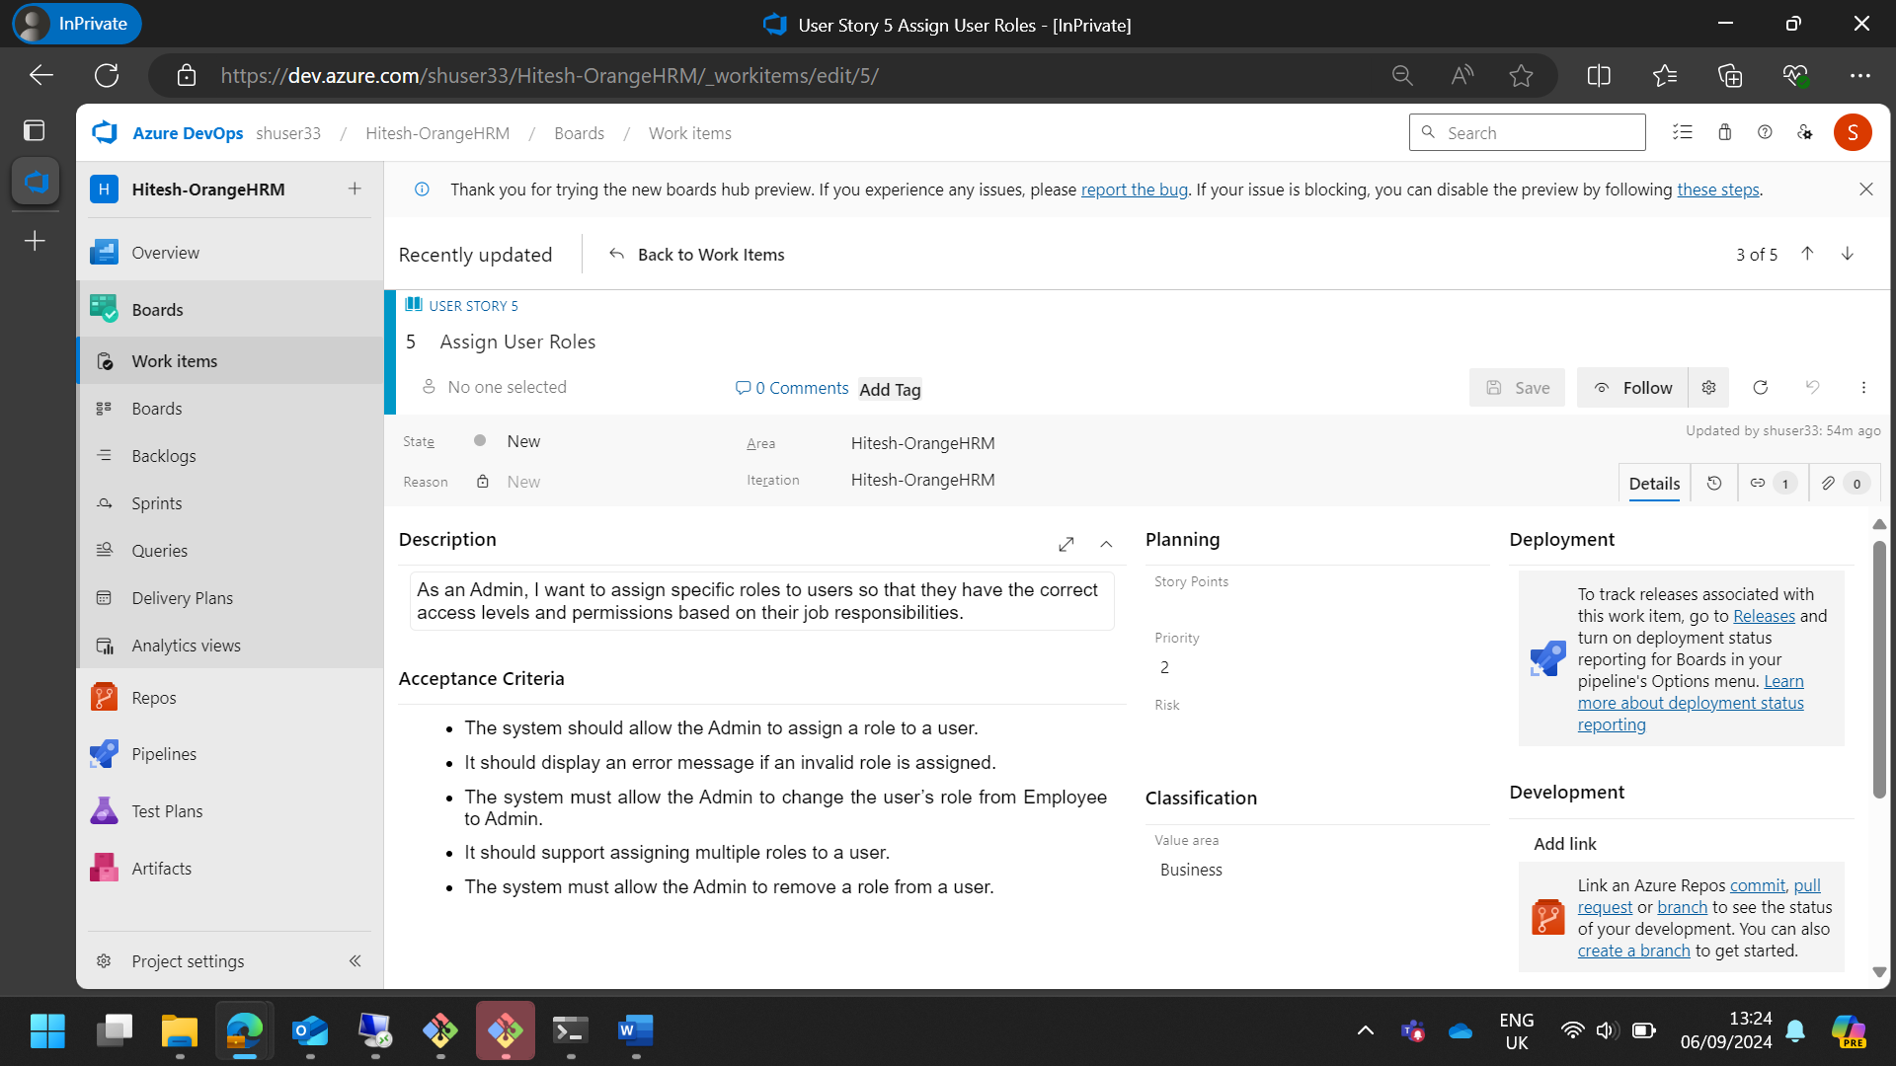

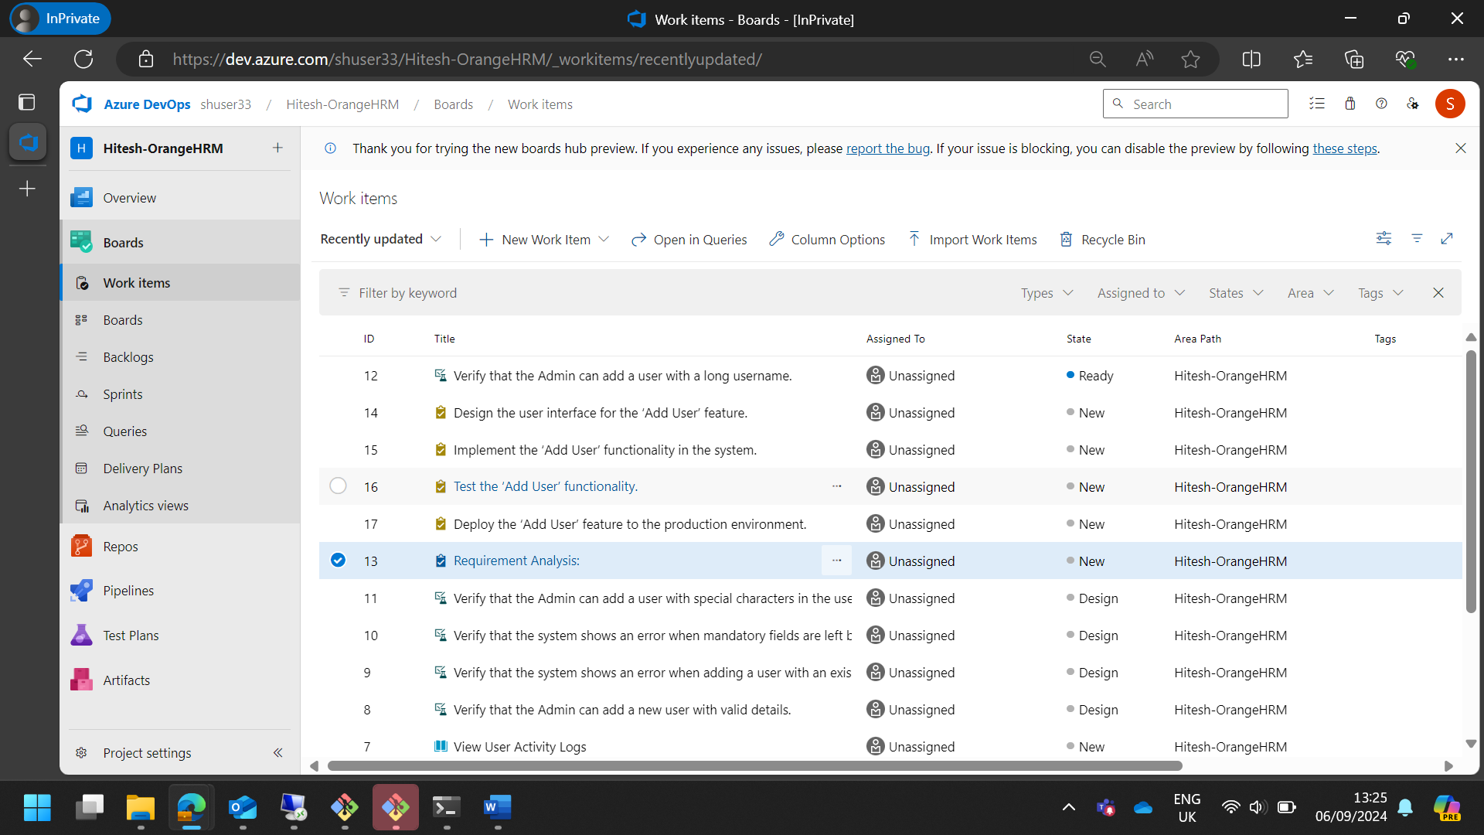

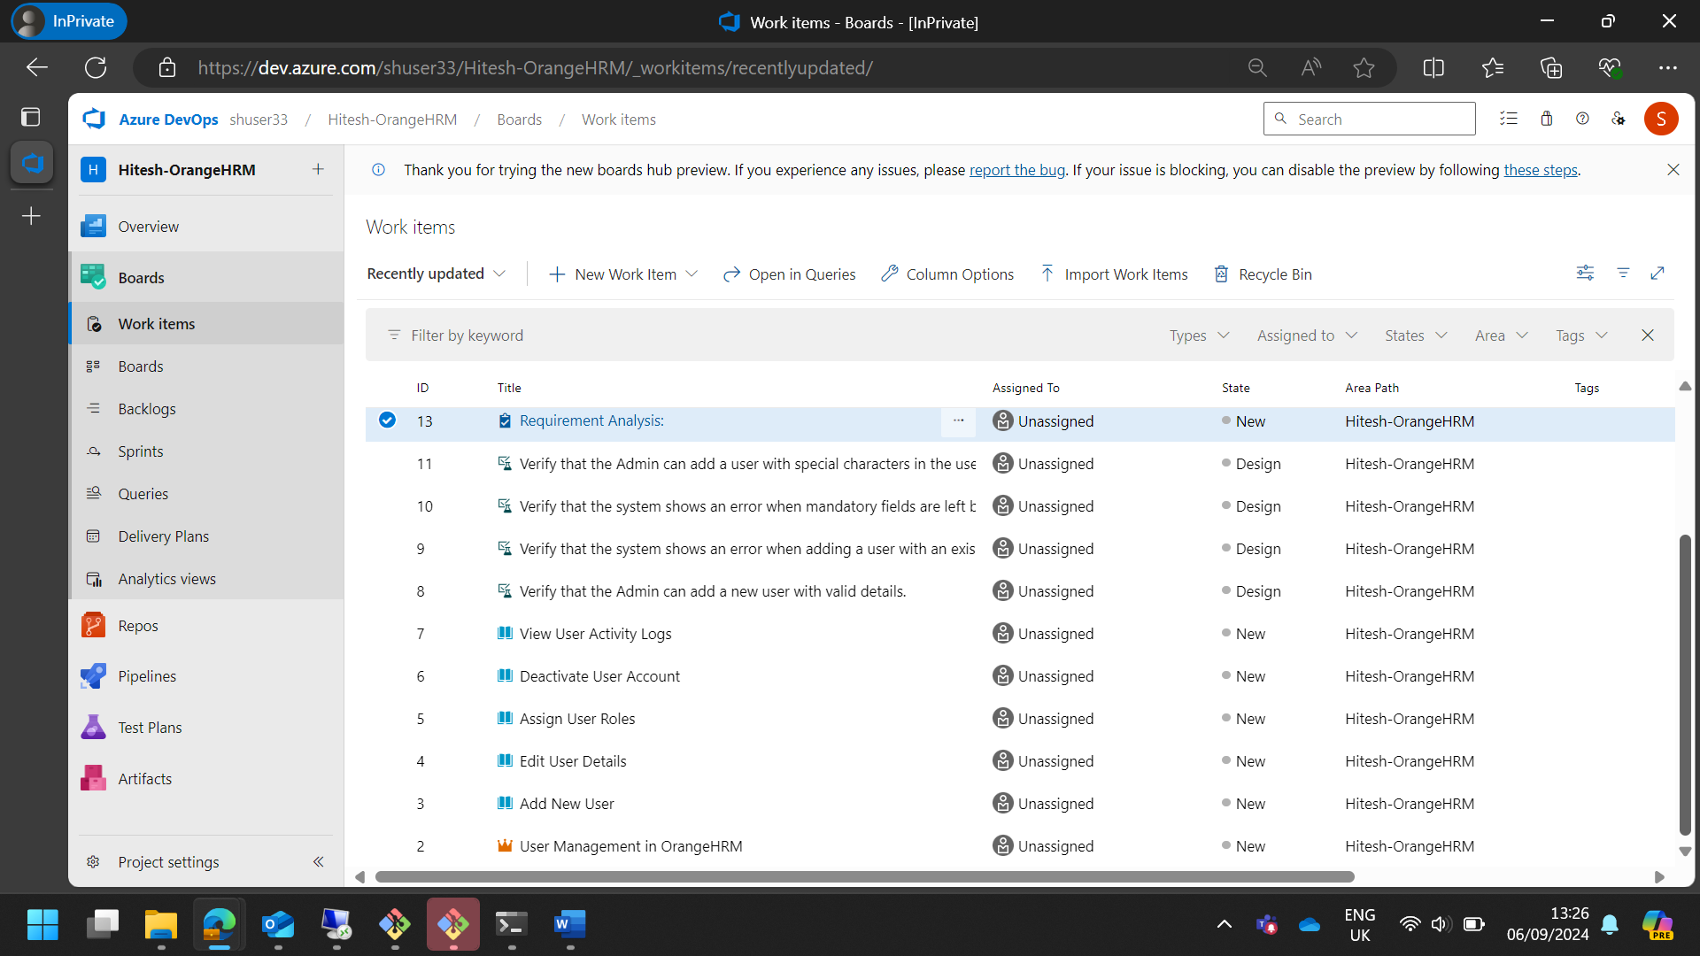

|  |
| --- |
| User Story 1: Add New User **Description:** As an Admin, I want to add new users to the system so that new employees can access the OrangeHRM platform with the appropriate permissions. **Feature:** User Management - Add New User **Benefit Hypothesis:** By allowing Admins to add new users to the system, OrangeHRM can ensure that new employees have timely access to the platform, improving onboarding efficiency and productivity.  **Tasks:**   1. **Requirement Analysis:**    * Task: Gather and document requirements for adding new users, including mandatory fields and validation rules.    * Description: Conduct meetings with stakeholders to understand the requirements for adding new users to the system. Document the required fields, validation rules, and any special conditions. 2. **Design:**    * Task: Design the user interface for the ‘Add User’ feature.    * Description: Create wireframes and mockups for the ‘Add User’ form, ensuring it includes all necessary fields and validation messages. 3. **Development:**    * Task: Implement the ‘Add User’ functionality in the system.    * Description: Develop the backend and frontend components required to add a new user, including form validation and database integration. 4. **Testing:**    * Task: Test the ‘Add User’ functionality.    * Description: *Create and execute test cases* to verify that the ‘Add User’ feature works as expected, including edge cases and error handling. 5. **Deployment:**    * Task: Deploy the ‘Add User’ feature to the production environment.    * Description: Prepare deployment scripts and documentation, and deploy the new feature to the live system. Monitor the deployment for any issues.   **Acceptance Criteria:**   * The system should allow the Admin to add a new user with valid details. * It should display an error message if the username already exists. * The system must require all mandatory fields to be filled before saving. * It should support usernames with special characters and long usernames. * The new user should be able to log in with the provided credentials after being added.  User Story 2: Edit User Details **Description:** As an Admin, I want to edit the details of existing users so that I can update their information, such as job title, department, or contact details.  **Feature:** User Management - Edit User Details **Benefit Hypothesis:** By enabling Admins to edit user details, OrangeHRM can maintain accurate and up-to-date employee information, which is crucial for effective HR management and communication.  **Tasks:**   1. **Requirement Analysis:**    * Task: Gather and document requirements for editing user details.    * Description: Conduct meetings with stakeholders to understand the requirements for editing user details, including which fields can be updated and any validation rules. 2. **Design:**    * Task: Design the user interface for the ‘Edit User Details’ feature.    * Description: Create wireframes and mockups for the ‘Edit User Details’ form, ensuring it includes all necessary fields and validation messages. 3. **Development:**    * Task: Implement the ‘Edit User Details’ functionality in the system.    * Description: Develop the backend and frontend components required to edit user details, including form validation and database updates. 4. **Testing:**    * Task: Test the ‘Edit User Details’ functionality.    * Description: Create and execute test cases to verify that the ‘Edit User Details’ feature works as expected, including edge cases and error handling. 5. **Deployment:**    * Task: Deploy the ‘Edit User Details’ feature to the production environment.    * Description: Prepare deployment scripts and documentation, and deploy the new feature to the live system. Monitor the deployment for any issues.   **Acceptance Criteria:**   * The system should allow the Admin to edit user details successfully. * It should display an error message if mandatory fields are left blank while editing. * The system must allow the Admin to change the user’s role. * It should support updating the user’s contact information. * The system must handle special characters in user details.  User Story 3: Assign User Roles **Description:** As an Admin, I want to assign specific roles to users so that they have the correct access levels and permissions based on their job responsibilities.  **Feature:** User Management - Assign User Roles **Benefit Hypothesis:** By allowing Admins to assign specific roles to users, OrangeHRM can ensure that employees have the correct access levels and permissions, enhancing security and role-based functionality.  **Tasks:**   1. **Requirement Analysis:**    * Task: Gather and document requirements for assigning user roles.    * Description: Conduct meetings with stakeholders to understand the requirements for assigning user roles, including the different roles and their permissions. 2. **Design:**    * Task: Design the user interface for the ‘Assign User Roles’ feature.    * Description: Create wireframes and mockups for the ‘Assign User Roles’ form, ensuring it includes all necessary fields and validation messages. 3. **Development:**    * Task: Implement the ‘Assign User Roles’ functionality in the system.    * Description: Develop the backend and frontend components required to assign user roles, including role validation and database updates. 4. **Testing:**    * Task: Test the ‘Assign User Roles’ functionality.    * Description: Create and execute test cases to verify that the ‘Assign User Roles’ feature works as expected, including edge cases and error handling. 5. **Deployment:**    * Task: Deploy the ‘Assign User Roles’ feature to the production environment.    * Description: Prepare deployment scripts and documentation, and deploy the new feature to the live system. Monitor the deployment for any issues.   **Acceptance Criteria:**   * The system should allow the Admin to assign a role to a user. * It should display an error message if an invalid role is assigned. * The system must allow the Admin to change the user’s role from Employee to Admin. * It should support assigning multiple roles to a user. * The system must allow the Admin to remove a role from a user.  User Story 4: Deactivate User Account **Description:** As an Admin, I want to deactivate user accounts so that former employees or users who no longer need access are removed from the system.  **Feature:** User Management - Deactivate User Account **Benefit Hypothesis:** By enabling Admins to deactivate user accounts, OrangeHRM can ensure that only current employees have access to the system, enhancing security and reducing unauthorized access.  **Tasks:**   1. **Requirement Analysis:**    * Task: Gather and document requirements for deactivating user accounts.    * Description: Conduct meetings with stakeholders to understand the requirements for deactivating user accounts, including any confirmation prompts and logging requirements. 2. **Design:**    * Task: Design the user interface for the ‘Deactivate User Account’ feature.    * Description: Create wireframes and mockups for the ‘Deactivate User Account’ form, ensuring it includes all necessary fields and validation messages. 3. **Development:**    * Task: Implement the ‘Deactivate User Account’ functionality in the system.    * Description: Develop the backend and frontend components required to deactivate user accounts, including confirmation prompts and database updates. 4. **Testing:**    * Task: Test the ‘Deactivate User Account’ functionality.    * Description: Create and execute test cases to verify that the ‘Deactivate User Account’ feature works as expected, including edge cases and error handling. 5. **Deployment:**    * Task: Deploy the ‘Deactivate User Account’ feature to the production environment.    * Description: Prepare deployment scripts and documentation, and deploy the new feature to the live system. Monitor the deployment for any issues.   **Acceptance Criteria:**   * The system should allow the Admin to deactivate a user account. * It must display a confirmation prompt before deactivation. * The deactivated user should not be able to log in to the system. * The system should allow the Admin to reactivate a deactivated user account. * It must log the deactivation action in the system.  User Story 5: View User Activity Logs **Description:** As an Admin, I want to view user activity logs so that I can monitor their actions and ensure compliance with company policies.  **Feature:** User Management - View User Activity Logs **Benefit Hypothesis:** By providing Admins with access to user activity logs, OrangeHRM can enhance monitoring and compliance, ensuring that user actions are tracked and any suspicious activities are identified promptly.  **Tasks:**   1. **Requirement Analysis:**    * Task: Gather and document requirements for viewing user activity logs.    * Description: Conduct meetings with stakeholders to understand the requirements for viewing user activity logs, including filter criteria and export options. 2. **Design:**    * Task: Design the user interface for the ‘View User Activity Logs’ feature.    * Description: Create wireframes and mockups for the ‘View User Activity Logs’ form, ensuring it includes all necessary fields and validation messages. 3. **Development:**    * Task: Implement the ‘View User Activity Logs’ functionality in the system.    * Description: Develop the backend and frontend components required to view user activity logs, including filtering and exporting options. 4. **Testing:**    * Task: Test the ‘View User Activity Logs’ functionality.    * Description: Create and execute test cases to verify that the ‘View User Activity Logs’ feature works as expected, including edge cases and error handling. 5. **Deployment:**    * Task: Deploy the ‘View User Activity Logs’ feature to the production environment.    * Description: Prepare deployment scripts and documentation, and deploy the new feature to the live system. Monitor the deployment for any issues.   **Acceptance Criteria:**   * The system should allow the Admin to view user activity logs. * It must display an error message if no logs are found for the filter criteria. * The system should allow the Admin to export user activity logs. * It must support filtering logs by user or date. * The system should provide detailed reports on user activities. |

1. Each user story should cover different aspects of the Software Development Life Cycle (SDLC) as it relates to the functionalities of the website.

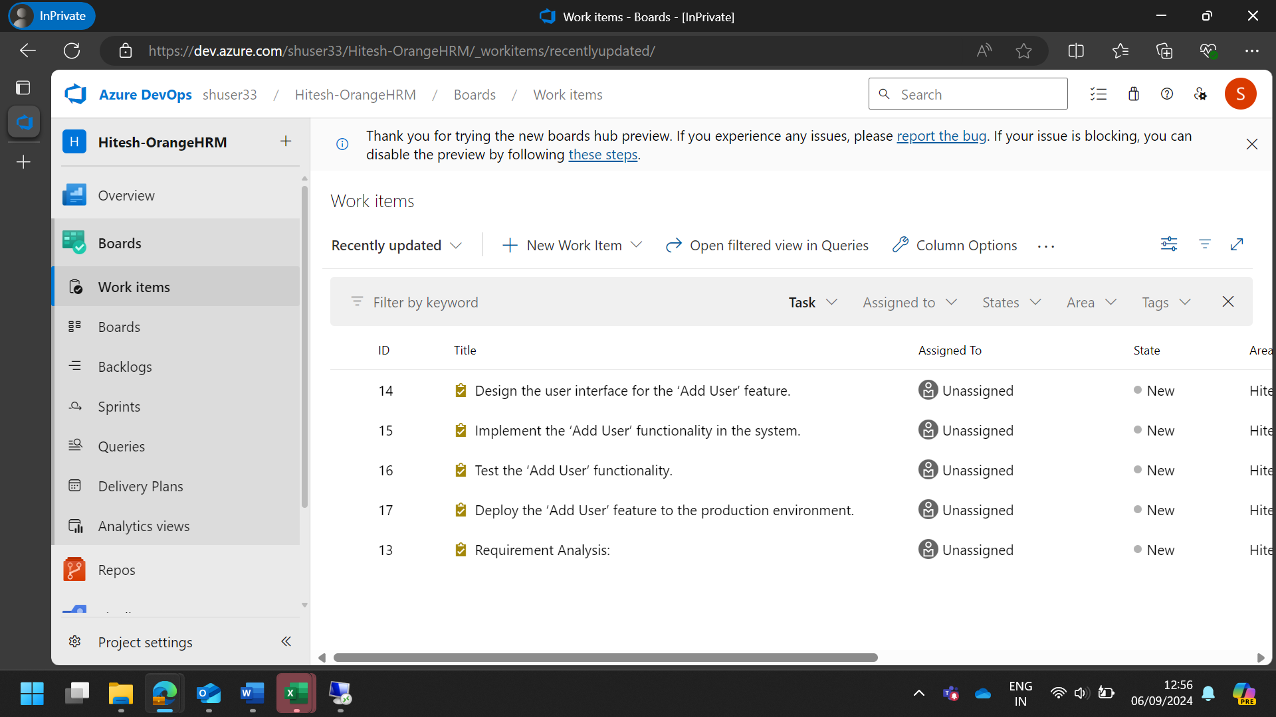

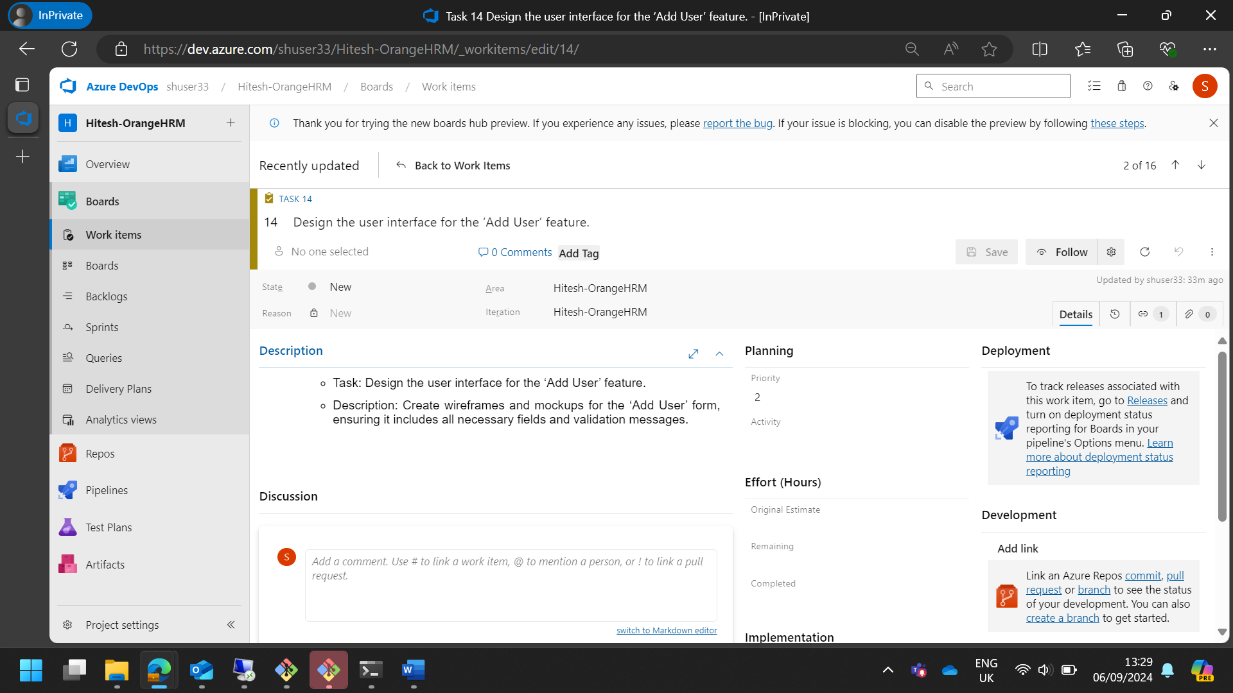

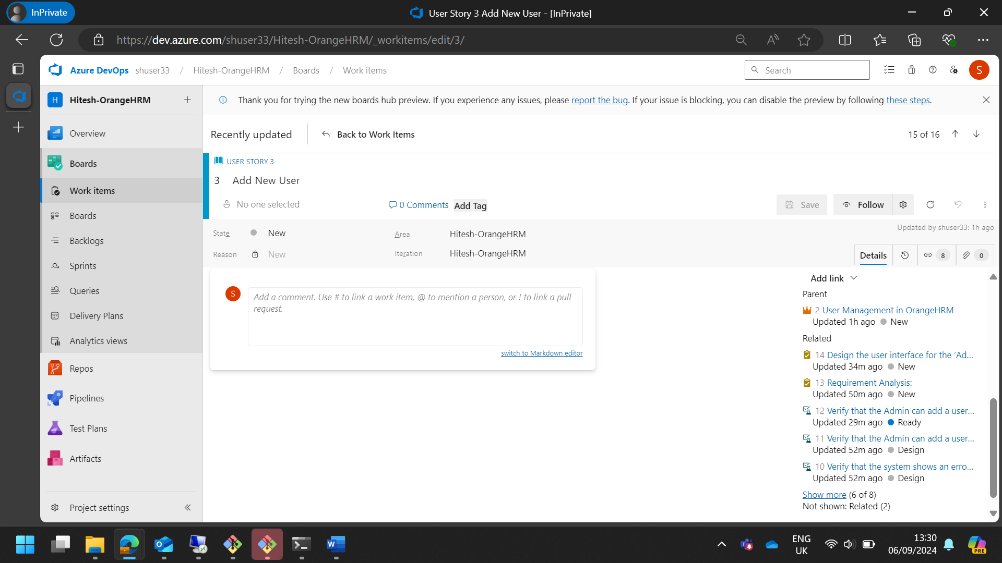

1. Create 25 test cases for the user stories created for the Sprint.

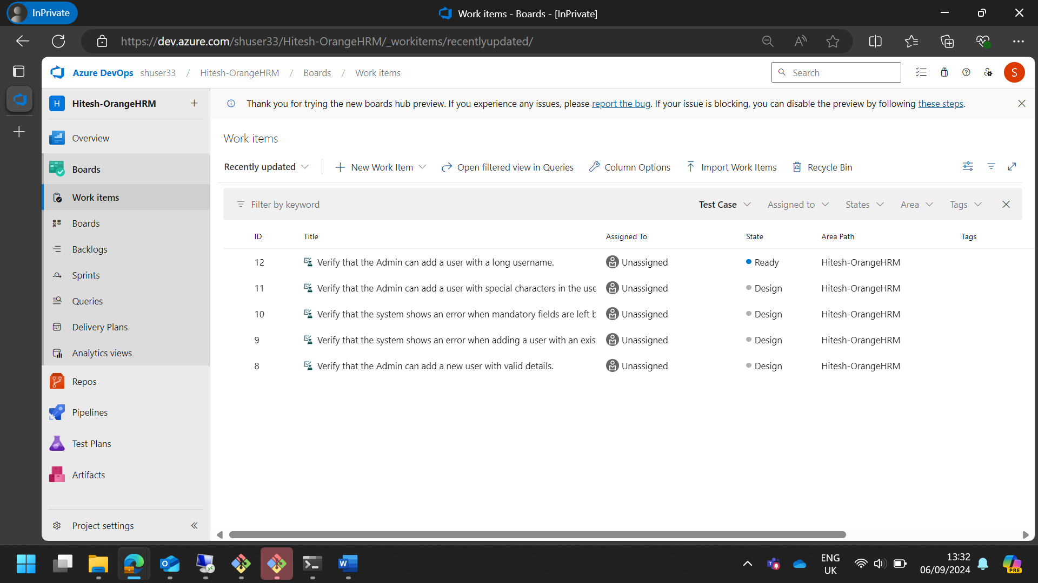

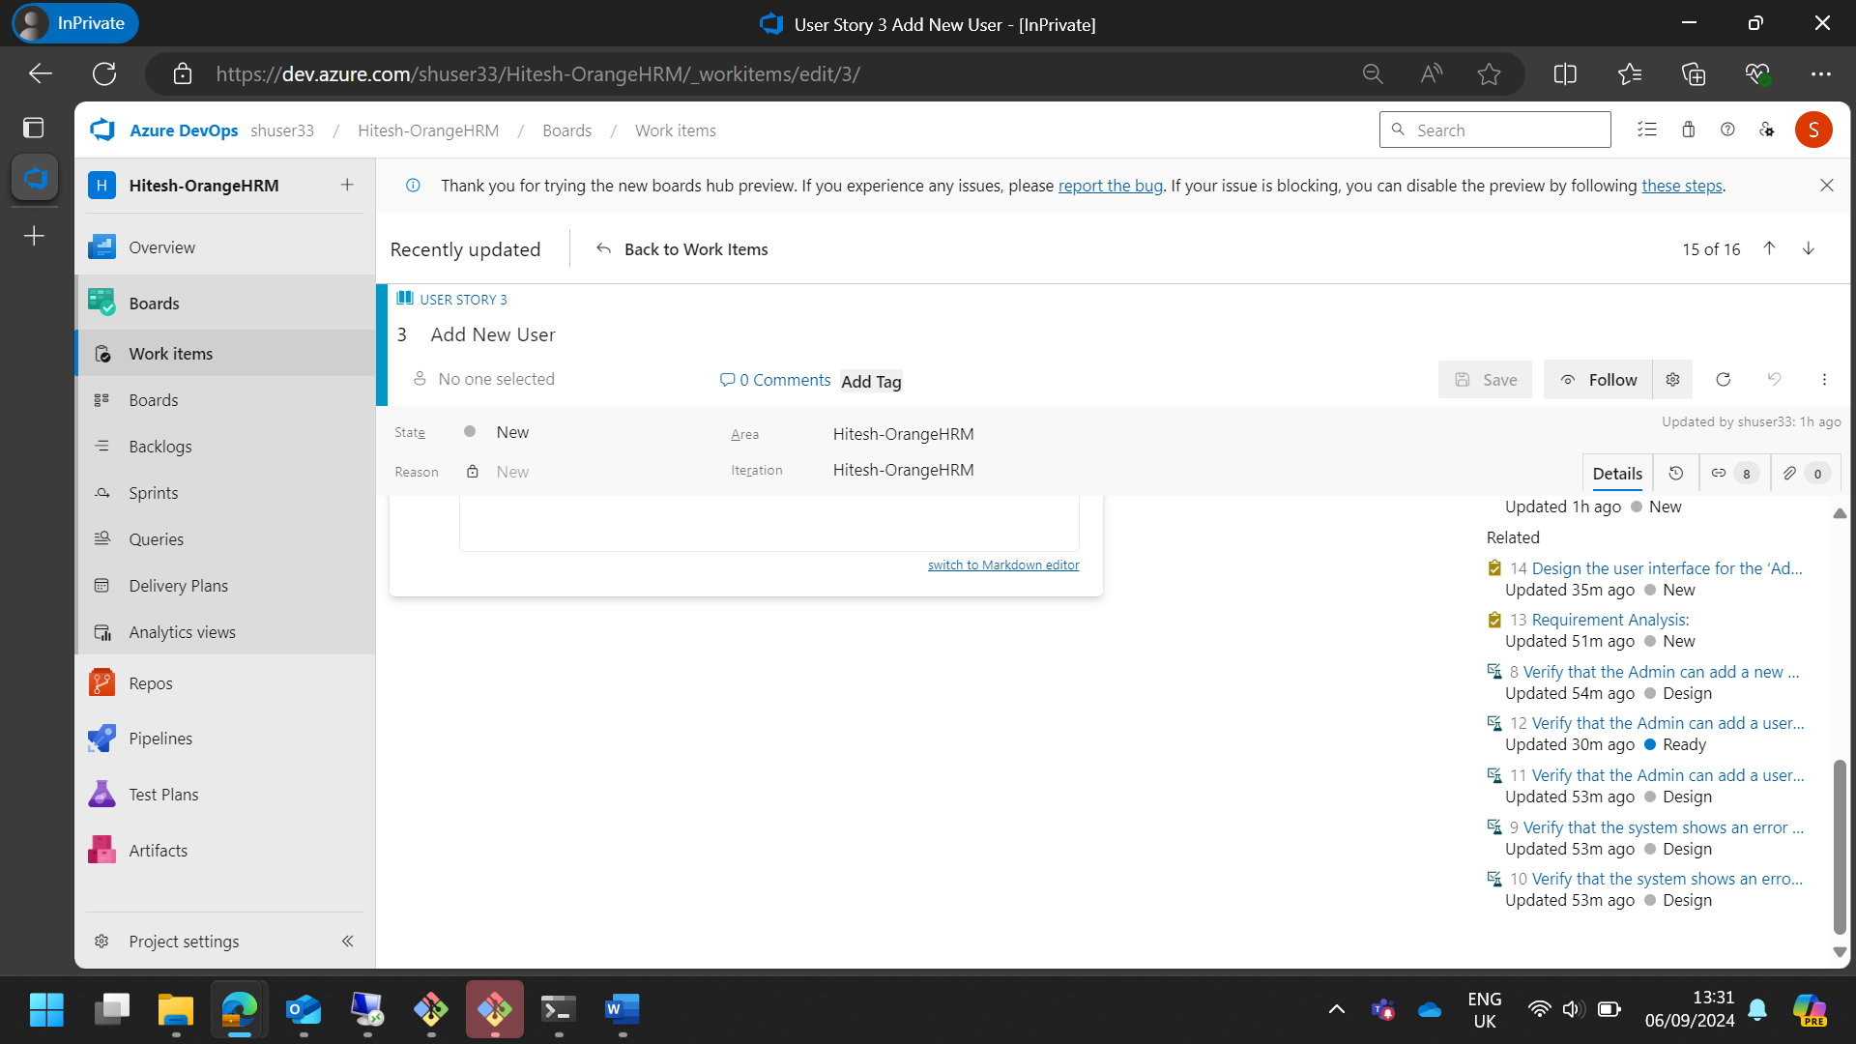

|  |  |  |  |  |  |  |
| --- | --- | --- | --- | --- | --- | --- |
| **Case Study: Orange-HRM** | | | | | | |
| **User Story 1: Add New User** | As an Admin, I want to add new users to the system so that new employees can access the OrangeHRM platform with the appropriate permissions. | | | | | |
|  | | | | | | |
| **Test Case ID** | **Test Case Description** | **Test Steps** | **Test Data** | **Expected Result** | **Actual Result** | **Status** |
| TC-01-01 | Verify that the Admin can add a new user with valid details. | 1. Navigate to the User Management section.   2. Click on ‘Add User’.   3. Enter valid user details.   4. Click ‘Save’. | New user details (e.g., username: Pigeon12 , password: key3389 , role: employee) | New user is added successfully and can log in with the provided credentials. | New user added successfully and logged in. | Passed |
| TC-01-02 | Verify that the system shows an error when adding a user with an existing username. | 1. Navigate to the User Management section.   2. Click on ‘Add User’.   3. Enter an existing username.   4. Click ‘Save’. | Existing username | System displays an error message indicating the username already exists. | Error message displayed as expected. | Passed |
| TC-01-03 | Verify that the system shows an error when mandatory fields are left blank. | 1. Navigate to the User Management section. 2. Click on ‘Add User’. 3. Leave mandatory fields blank. 4. Click ‘Save’. | Incomplete user details | System displays an error message indicating mandatory fields are required. | No error message displayed. | Failed |
| TC-01-04 | Verify that the Admin can add a user with special characters in the username. | 1. Navigate to the User Management section. 2. Click on ‘Add User’. 3. Enter a username with special characters. 4. Click ‘Save’. | Username with special characters | New user is added successfully and can log in with the provided credentials. | New user added but unable to log in. | Failed |
| TC-01-05 | Verify that the Admin can add a user with a long username. | 1. Navigate to the User Management section. 2. Click on ‘Add User’. 3. Enter a long username. 4. Click ‘Save’. | Long username | New user is added successfully and can log in with the provided credentials. | New user added successfully and logged in. | Passed |

|  |  |  |  |  |  |  |
| --- | --- | --- | --- | --- | --- | --- |
| **Case Study: Orange-HRM** | | | | | | |
| **User Story 2: Edit User Details** | As an Admin, I want to edit the details of existing users so that I can update their information, such as job title, department, or contact details. | | | | | |
|  |  |  |  |  |  |  |
| **Test Case ID** | **Test Case Description** | **Test Steps** | **Test Data** | **Expected Result** | **Actual Result** | **Status** |
| TC-02-01 | Verify that the Admin can edit user details successfully. | 1. Navigate to the User Management section. 2. Select an existing user. 3. Click ‘Edit’. 4. Update user details. 5. Click ‘Save’. | Updated user details (e.g., job title, department) | User details are updated successfully. | User details updated successfully. | Passed |
| TC-02-02 | Verify that the system shows an error when mandatory fields are left blank while editing. | 1. Navigate to the User Management section. 2. Select an existing user. 3. Click ‘Edit’. 4. Clear mandatory fields. 5. Click ‘Save’. | Incomplete user details | System displays an error message indicating mandatory fields are required. | Error message displayed as expected. | Passed |
| TC-02-03 | Verify that the Admin can change the user’s role. | 1. Navigate to the User Management section. 2. Select an existing user. 3. Click ‘Edit’. 4. Change the user’s role. 5. Click ‘Save’. | New role details | User role is updated successfully. | User role updated successfully. | Passed |
| TC-02-04 | Verify that the Admin can update the user’s contact information. | 1. Navigate to the User Management section. 2. Select an existing user. 3. Click ‘Edit’. 4. Update contact information. 5. Click ‘Save’. | New contact information | User contact information is updated successfully. | Contact information not updated. | Failed |
| TC-02-05 | Verify that the Admin can edit user details with special characters. | 1. Navigate to the User Management section. 2. Select an existing user. 3. Click ‘Edit’. 4. Enter details with special characters. 5. Click ‘Save’. | Details with special characters | User details are updated successfully. | User details updated successfully. | Passed |

|  |  |  |  |  |  |  |
| --- | --- | --- | --- | --- | --- | --- |
| **Case Study: Orange-HRM** | | | | | | |
| **User Story 3: Assign User Roles** | As an Admin, I want to assign specific roles to users so that they have the correct access levels and permissions based on their job responsibilities. | | | | | |
|  |  |  |  |  |  |  |
| **Test Case ID** | **Test Case Description** | **Test Steps** | **Test Data** | **Expected Result** | **Actual Result** | **Status** |
| TC-03-01 | Verify that the Admin can assign a role to a user. | 1. Navigate to the User Management section. 2. Select an existing user. 3. Click ‘Edit’. 4. Assign a role to the user. 5. Click ‘Save’. | Role details (e.g., Admin, Employee) | User is assigned the specified role successfully. | User assigned role successfully. | Passed |
| TC-03-02 | Verify that the system shows an error when assigning an invalid role. | 1. Navigate to the User Management section. 2. Select an existing user. 3. Click ‘Edit’. 4. Assign an invalid role. 5. Click ‘Save’. | Invalid role details | System displays an error message indicating the role is invalid. | Error message not displayed. | Failed |
| TC-03-03 | Verify that the Admin can change the user’s role from Employee to Admin. | 1. Navigate to the User Management section. 2. Select an existing user with the role ‘Employee’. 3. Click ‘Edit’. 4. Change the role to ‘Admin’. 5. Click ‘Save’. | Role change details | User role is updated to ‘Admin’ successfully. | User role updated to ‘Admin’ successfully. | Passed |
| TC-03-04 | Verify that the Admin can assign multiple roles to a user. | 1. Navigate to the User Management section. 2. Select an existing user. 3. Click ‘Edit’. 4. Assign multiple roles to the user. 5. Click ‘Save’. | Multiple role details | User is assigned multiple roles successfully. | User assigned multiple roles successfully. | Passed |
| TC-03-05 | Verify that the Admin can remove a role from a user. | 1. Navigate to the User Management section. 2. Select an existing user. 3. Click ‘Edit’. 4. Remove a role from the user. 5. Click ‘Save’. | Role removal details | User role is removed successfully. | User role not removed. | Failed |

|  |  |  |  |  |  |  |
| --- | --- | --- | --- | --- | --- | --- |
| **Case Study: Orange-HRM** | | | | | | |
| **User Story 4: Deactivate User Account** | As an Admin, I want to deactivate user accounts so that former employees or users who no longer need access are removed from the system. | | | | | |
|  |  |  |  |  |  |  |
| **Test Case ID** | **Test Case Description** | **Test Steps** | **Test Data** | **Expected Result** | **Actual Result** | **Status** |
| TC-04-01 | Verify that the Admin can deactivate a user account. | 1. Navigate to the User Management section. 2. Select an existing user. 3. Click ‘Deactivate’. 4. Confirm deactivation. | User account details | User account is deactivated successfully. | User account deactivated successfully. | Passed |
| TC-04-02 | Verify that the system shows a confirmation prompt before deactivation. | 1. Navigate to the User Management section. 2. Select an existing user. 3. Click ‘Deactivate’. | User account details | System displays a confirmation prompt before deactivation. | Confirmation prompt displayed as expected. | Passed |
| TC-04-03 | Verify that the deactivated user cannot log in to the system. | 1. Deactivate a user account. 2. Attempt to log in with the deactivated user credentials. | Deactivated user credentials | Deactivated user cannot log in to the system. | Deactivated user able to log in. | Failed |
| TC-04-04 | Verify that the Admin can reactivate a deactivated user account. | 1. Navigate to the User Management section. 2. Select a deactivated user. 3. Click ‘Reactivate’. 4. Confirm reactivation. | Deactivated user account details | User account is reactivated successfully. | User account reactivated successfully. | Passed |
| TC-04-05 | Verify that the system logs the deactivation action. | 1. Deactivate a user account. 2. Navigate to the Activity Logs section. 3. Filter logs by the deactivated user. | Deactivated user account details | Deactivation action is logged in the system. | Deactivation action not logged. | Failed |

|  |  |  |  |  |  |  |
| --- | --- | --- | --- | --- | --- | --- |
| **Case Study: Orange-HRM** | | | | | | |
| **User Story 5: View User Activity Logs** | As an Admin, I want to view user activity logs so that I can monitor their actions and ensure compliance with company policies. | | | | | |
|  |  |  |  |  |  |  |
| **Test Case ID** | **Test Case Description** | **Test Steps** | **Test Data** | **Expected Result** | **Actual Result** | **Status** |
| TC-05-01 | Verify that the Admin can view user activity logs. | 1. Navigate to the User Management section. 2. Select ‘Activity Logs’. 3. Filter logs by user or date. | Filter criteria (e.g., user name, date range) | Activity logs are displayed as per the filter criteria. | Activity logs displayed as expected. | Passed |
| TC-05-02 | Verify that the system shows an error when no logs are found for the filter criteria. | 1. Navigate to the User Management section. 2. Select ‘Activity Logs’. 3. Apply filter criteria with no matching logs. | Filter criteria with no matching logs | System displays an error message indicating no logs found. | Error message displayed as expected. | Passed |
| TC-05-03 | Verify that the Admin can export user activity logs. | 1. Navigate to the User Management section. 2. Select ‘Activity Logs’. 3. Click ‘Export’. | Export criteria (e.g., file format) | Activity logs are exported successfully. | Export failed due to format error. | Failed |
| TC-05-04 | Verify that the system supports filtering logs by user. | 1. Navigate to the User Management section. 2. Select ‘Activity Logs’. 3. Filter logs by user. | User filter criteria | Activity logs filtered by user are displayed. | Logs filtered by user displayed as expected. | Passed |
| TC-05-05 | Verify that the system provides detailed reports on user activities. | 1. Navigate to the User Management section. 2. Select ‘Activity Logs’. 3. Generate a detailed report. | Report criteria (e.g., date range, user) | Detailed report on user activities is generated. | Report generation failed. | Failed |

1. Define the tasks and sub tasks for each User Story.

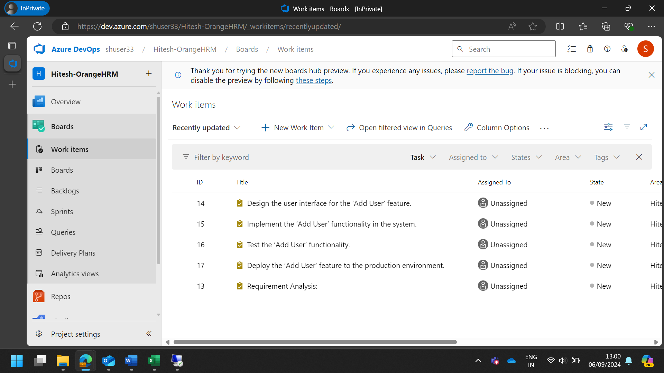

1. Execute all the test cases manually (functional testing).

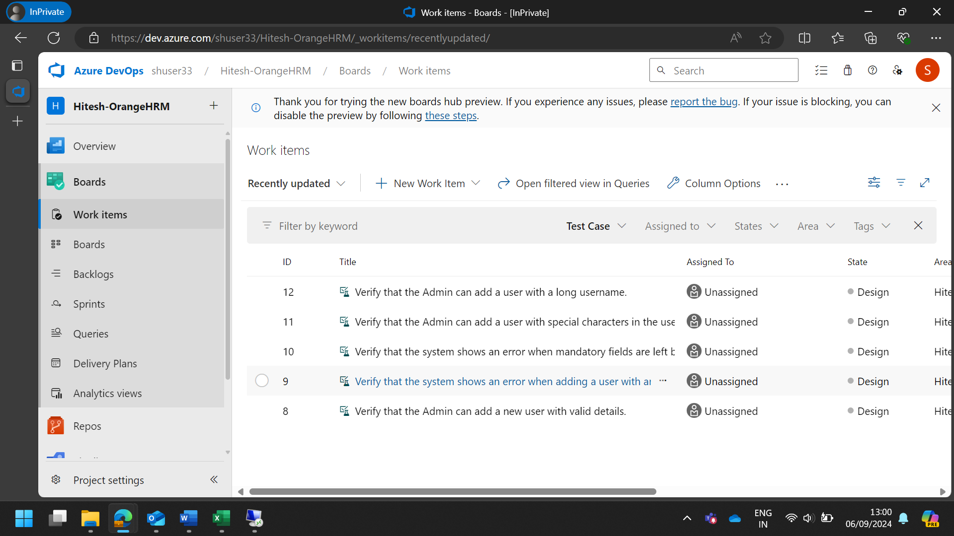

|  |  |  |  |  |  |  |
| --- | --- | --- | --- | --- | --- | --- |
| **Case Study: Orange-HRM** | | | | | | |
| **User Story 1: Add New User** | As an Admin, I want to add new users to the system so that new employees can access the OrangeHRM platform with the appropriate permissions. | | | | | |
|  | | | | | | |
| **Test Case ID** | **Test Case Description** | **Test Steps** | **Test Data** | **Expected Result** | **Actual Result** | **Status** |
| TC-01-01 | Verify that the Admin can add a new user with valid details. | 1. Navigate to the User Management section.   2. Click on ‘Add User’.   3. Enter valid user details.   4. Click ‘Save’. | New user details (e.g., username: Pigeon12 , password: key3389 , role: employee) | New user is added successfully and can log in with the provided credentials. | New user added successfully and logged in. | Passed |
| TC-01-02 | Verify that the system shows an error when adding a user with an existing username. | 1. Navigate to the User Management section.   2. Click on ‘Add User’.   3. Enter an existing username.   4. Click ‘Save’. | Existing username | System displays an error message indicating the username already exists. | Error message displayed as expected. | Passed |
| TC-01-03 | Verify that the system shows an error when mandatory fields are left blank. | 1. Navigate to the User Management section. 2. Click on ‘Add User’. 3. Leave mandatory fields blank. 4. Click ‘Save’. | Incomplete user details | System displays an error message indicating mandatory fields are required. | No error message displayed. | Failed |
| TC-01-04 | Verify that the Admin can add a user with special characters in the username. | 1. Navigate to the User Management section. 2. Click on ‘Add User’. 3. Enter a username with special characters. 4. Click ‘Save’. | Username with special characters | New user is added successfully and can log in with the provided credentials. | New user added but unable to log in. | Failed |
| TC-01-05 | Verify that the Admin can add a user with a long username. | 1. Navigate to the User Management section. 2. Click on ‘Add User’. 3. Enter a long username. 4. Click ‘Save’. | Long username | New user is added successfully and can log in with the provided credentials. | New user added successfully and logged in. | Passed |

|  |  |  |  |  |  |  |
| --- | --- | --- | --- | --- | --- | --- |
| **Case Study: Orange-HRM** | | | | | | |
| **User Story 2: Edit User Details** | As an Admin, I want to edit the details of existing users so that I can update their information, such as job title, department, or contact details. | | | | | |
|  |  |  |  |  |  |  |
| **Test Case ID** | **Test Case Description** | **Test Steps** | **Test Data** | **Expected Result** | **Actual Result** | **Status** |
| TC-02-01 | Verify that the Admin can edit user details successfully. | 1. Navigate to the User Management section. 2. Select an existing user. 3. Click ‘Edit’. 4. Update user details. 5. Click ‘Save’. | Updated user details (e.g., job title, department) | User details are updated successfully. | User details updated successfully. | Passed |
| TC-02-02 | Verify that the system shows an error when mandatory fields are left blank while editing. | 1. Navigate to the User Management section. 2. Select an existing user. 3. Click ‘Edit’. 4. Clear mandatory fields. 5. Click ‘Save’. | Incomplete user details | System displays an error message indicating mandatory fields are required. | Error message displayed as expected. | Passed |
| TC-02-03 | Verify that the Admin can change the user’s role. | 1. Navigate to the User Management section. 2. Select an existing user. 3. Click ‘Edit’. 4. Change the user’s role. 5. Click ‘Save’. | New role details | User role is updated successfully. | User role updated successfully. | Passed |
| TC-02-04 | Verify that the Admin can update the user’s contact information. | 1. Navigate to the User Management section. 2. Select an existing user. 3. Click ‘Edit’. 4. Update contact information. 5. Click ‘Save’. | New contact information | User contact information is updated successfully. | Contact information not updated. | Failed |
| TC-02-05 | Verify that the Admin can edit user details with special characters. | 1. Navigate to the User Management section. 2. Select an existing user. 3. Click ‘Edit’. 4. Enter details with special characters. 5. Click ‘Save’. | Details with special characters | User details are updated successfully. | User details updated successfully. | Passed |

|  |  |  |  |  |  |  |
| --- | --- | --- | --- | --- | --- | --- |
| **Case Study: Orange-HRM** | | | | | | |
| **User Story 3: Assign User Roles** | As an Admin, I want to assign specific roles to users so that they have the correct access levels and permissions based on their job responsibilities. | | | | | |
|  |  |  |  |  |  |  |
| **Test Case ID** | **Test Case Description** | **Test Steps** | **Test Data** | **Expected Result** | **Actual Result** | **Status** |
| TC-03-01 | Verify that the Admin can assign a role to a user. | 1. Navigate to the User Management section. 2. Select an existing user. 3. Click ‘Edit’. 4. Assign a role to the user. 5. Click ‘Save’. | Role details (e.g., Admin, Employee) | User is assigned the specified role successfully. | User assigned role successfully. | Passed |
| TC-03-02 | Verify that the system shows an error when assigning an invalid role. | 1. Navigate to the User Management section. 2. Select an existing user. 3. Click ‘Edit’. 4. Assign an invalid role. 5. Click ‘Save’. | Invalid role details | System displays an error message indicating the role is invalid. | Error message not displayed. | Failed |
| TC-03-03 | Verify that the Admin can change the user’s role from Employee to Admin. | 1. Navigate to the User Management section. 2. Select an existing user with the role ‘Employee’. 3. Click ‘Edit’. 4. Change the role to ‘Admin’. 5. Click ‘Save’. | Role change details | User role is updated to ‘Admin’ successfully. | User role updated to ‘Admin’ successfully. | Passed |
| TC-03-04 | Verify that the Admin can assign multiple roles to a user. | 1. Navigate to the User Management section. 2. Select an existing user. 3. Click ‘Edit’. 4. Assign multiple roles to the user. 5. Click ‘Save’. | Multiple role details | User is assigned multiple roles successfully. | User assigned multiple roles successfully. | Passed |
| TC-03-05 | Verify that the Admin can remove a role from a user. | 1. Navigate to the User Management section. 2. Select an existing user. 3. Click ‘Edit’. 4. Remove a role from the user. 5. Click ‘Save’. | Role removal details | User role is removed successfully. | User role not removed. | Failed |

|  |  |  |  |  |  |  |
| --- | --- | --- | --- | --- | --- | --- |
| **Case Study: Orange-HRM** | | | | | | |
| **User Story 4: Deactivate User Account** | As an Admin, I want to deactivate user accounts so that former employees or users who no longer need access are removed from the system. | | | | | |
|  |  |  |  |  |  |  |
| **Test Case ID** | **Test Case Description** | **Test Steps** | **Test Data** | **Expected Result** | **Actual Result** | **Status** |
| TC-04-01 | Verify that the Admin can deactivate a user account. | 1. Navigate to the User Management section. 2. Select an existing user. 3. Click ‘Deactivate’. 4. Confirm deactivation. | User account details | User account is deactivated successfully. | User account deactivated successfully. | Passed |
| TC-04-02 | Verify that the system shows a confirmation prompt before deactivation. | 1. Navigate to the User Management section. 2. Select an existing user. 3. Click ‘Deactivate’. | User account details | System displays a confirmation prompt before deactivation. | Confirmation prompt displayed as expected. | Passed |
| TC-04-03 | Verify that the deactivated user cannot log in to the system. | 1. Deactivate a user account. 2. Attempt to log in with the deactivated user credentials. | Deactivated user credentials | Deactivated user cannot log in to the system. | Deactivated user able to log in. | Failed |
| TC-04-04 | Verify that the Admin can reactivate a deactivated user account. | 1. Navigate to the User Management section. 2. Select a deactivated user. 3. Click ‘Reactivate’. 4. Confirm reactivation. | Deactivated user account details | User account is reactivated successfully. | User account reactivated successfully. | Passed |
| TC-04-05 | Verify that the system logs the deactivation action. | 1. Deactivate a user account. 2. Navigate to the Activity Logs section. 3. Filter logs by the deactivated user. | Deactivated user account details | Deactivation action is logged in the system. | Deactivation action not logged. | Failed |

|  |  |  |  |  |  |  |
| --- | --- | --- | --- | --- | --- | --- |
| **Case Study: Orange-HRM** | | | | | | |
| **User Story 5: View User Activity Logs** | As an Admin, I want to view user activity logs so that I can monitor their actions and ensure compliance with company policies. | | | | | |
|  |  |  |  |  |  |  |
| **Test Case ID** | **Test Case Description** | **Test Steps** | **Test Data** | **Expected Result** | **Actual Result** | **Status** |
| TC-05-01 | Verify that the Admin can view user activity logs. | 1. Navigate to the User Management section. 2. Select ‘Activity Logs’. 3. Filter logs by user or date. | Filter criteria (e.g., user name, date range) | Activity logs are displayed as per the filter criteria. | Activity logs displayed as expected. | Passed |
| TC-05-02 | Verify that the system shows an error when no logs are found for the filter criteria. | 1. Navigate to the User Management section. 2. Select ‘Activity Logs’. 3. Apply filter criteria with no matching logs. | Filter criteria with no matching logs | System displays an error message indicating no logs found. | Error message displayed as expected. | Passed |
| TC-05-03 | Verify that the Admin can export user activity logs. | 1. Navigate to the User Management section. 2. Select ‘Activity Logs’. 3. Click ‘Export’. | Export criteria (e.g., file format) | Activity logs are exported successfully. | Export failed due to format error. | Failed |
| TC-05-04 | Verify that the system supports filtering logs by user. | 1. Navigate to the User Management section. 2. Select ‘Activity Logs’. 3. Filter logs by user. | User filter criteria | Activity logs filtered by user are displayed. | Logs filtered by user displayed as expected. | Passed |
| TC-05-05 | Verify that the system provides detailed reports on user activities. | 1. Navigate to the User Management section. 2. Select ‘Activity Logs’. 3. Generate a detailed report. | Report criteria (e.g., date range, user) | Detailed report on user activities is generated. | Report generation failed. | Failed |

1. Create a Defect Report for each failed or blocked test case.

* Employee ID accepting alphabets.

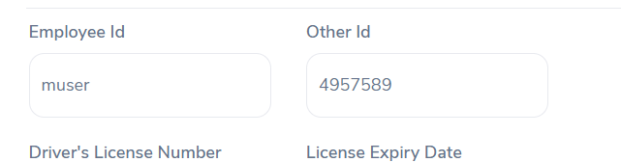

* Special characters like “@” in the name.

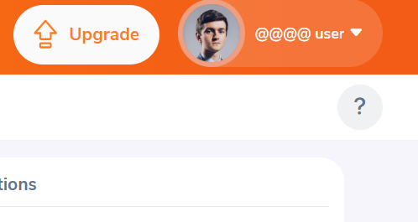

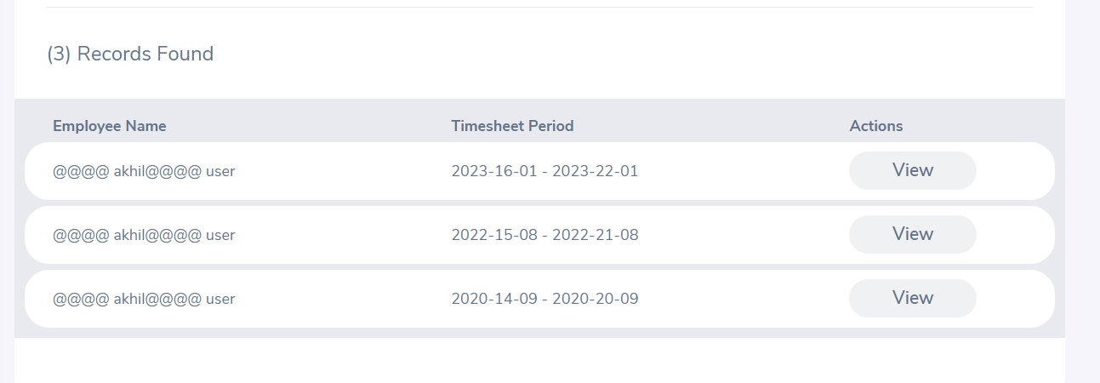

* Incorrect Time instance for user

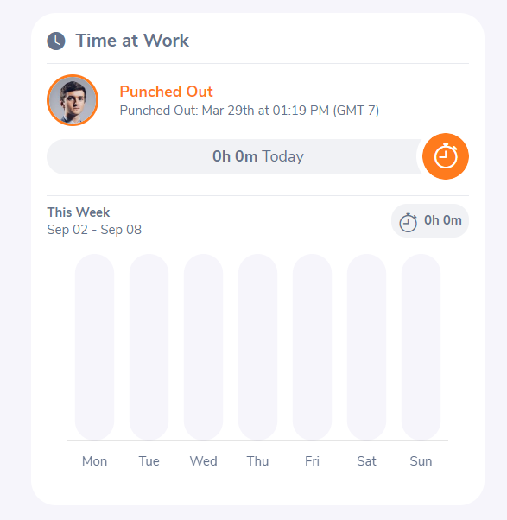

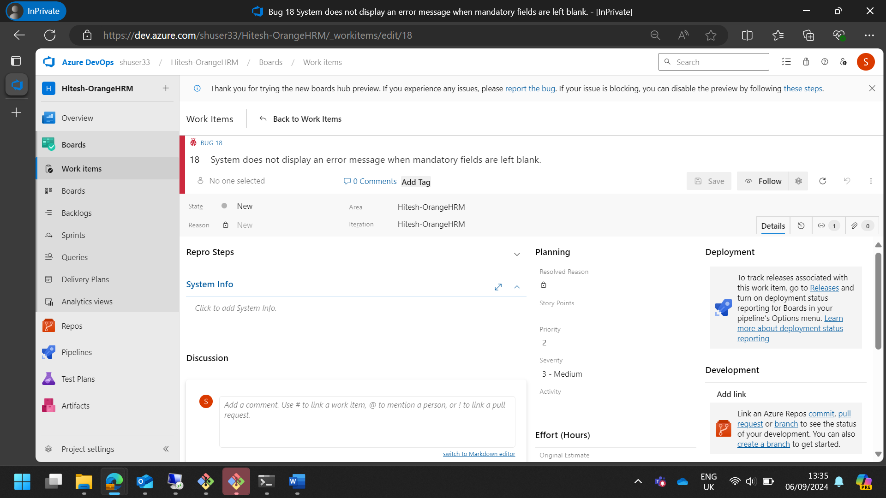

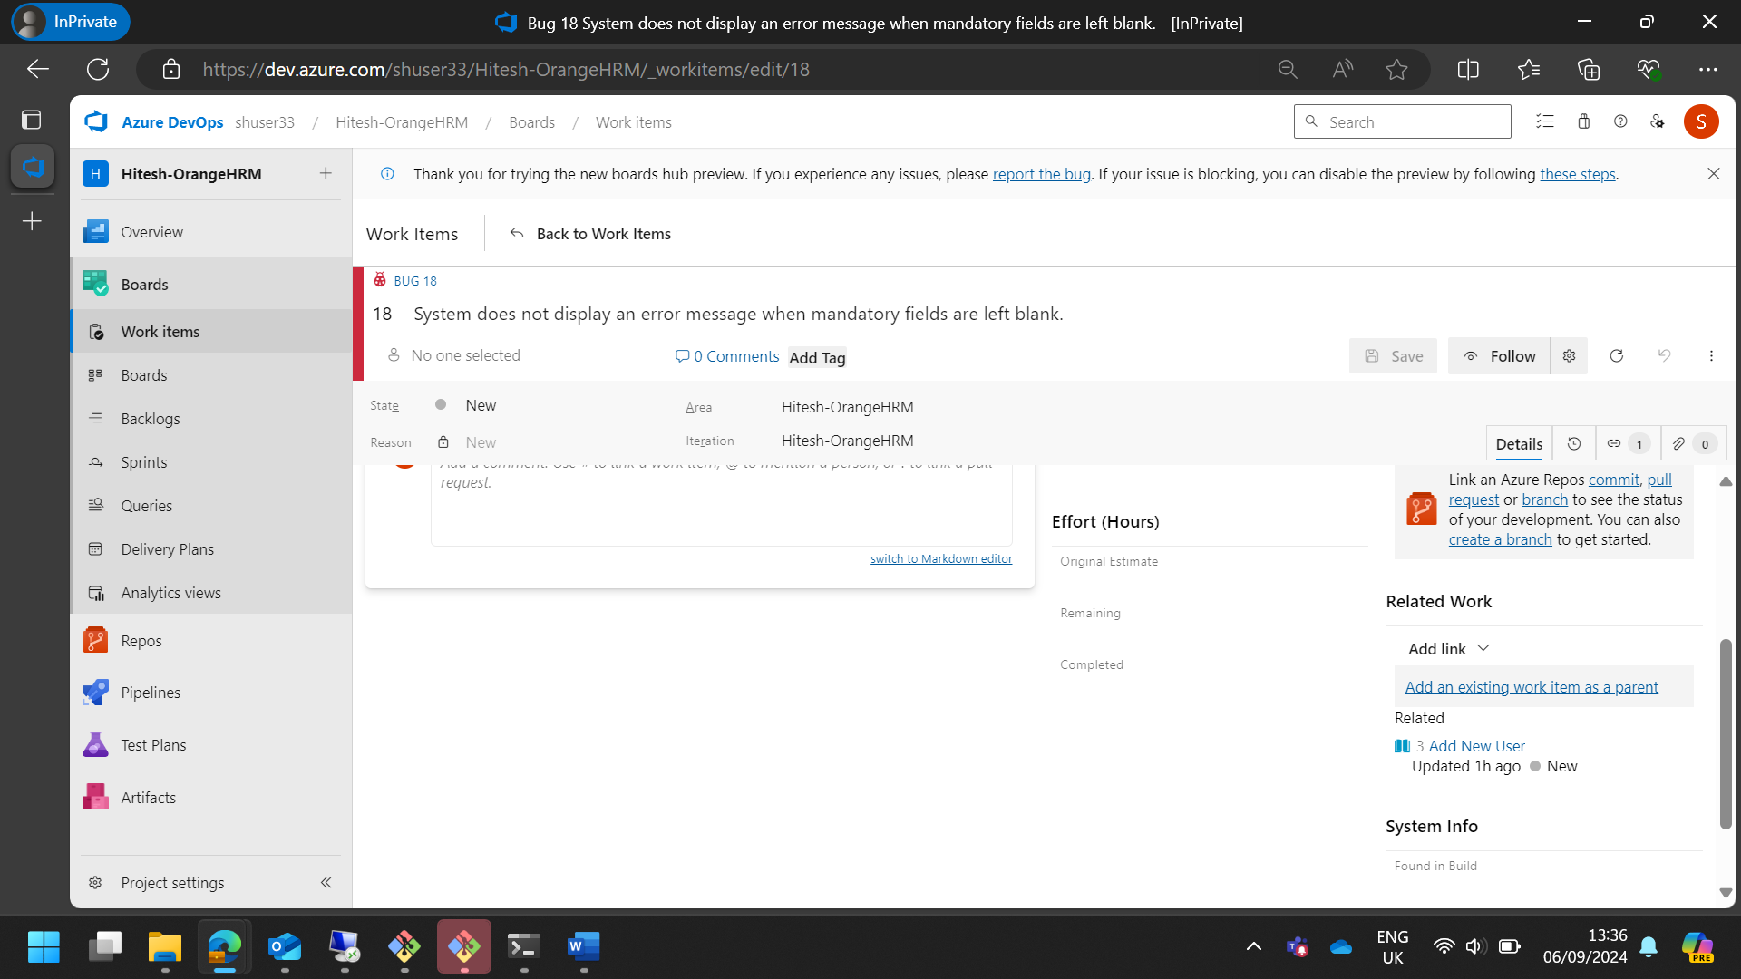

|  |  |  |  |  |  |  |  |
| --- | --- | --- | --- | --- | --- | --- | --- |
| **OrangeHRM Case Study Defect Report** | | | | | | | |
| **Defect ID** | **Test Case ID** | **User Story** | **Defect Description** | **Reason** | **Severity** | **Priority** | **Status** |
| D-01 | TC-01-03 | User Story 1: Add New User | System does not display an error message when mandatory fields are left blank. | Validation issue | High | High | Open |
| D-02 | TC-01-04 | User Story 1: Add New User | Special characters like “@” in the name. | Special character handling | Medium | Medium | Open |
| D-03 | TC-02-04 | User Story 2: Edit User Details | Employee ID accepting alphabets. | Data update issue | Medium | Medium | Open |
| D-04 | TC-03-02 | User Story 3: Assign User Roles | System does not display an error message when assigning an invalid role. | Validation issue | High | High | Open |
| D-05 | TC-03-05 | User Story 3: Assign User Roles | User role not removed. | Data update issue | Medium | Medium | Open |
| D-06 | TC-04-03 | User Story 4: Deactivate User Account | Deactivated user able to log in. | Deactivation issue | High | High | Open |
| D-07 | TC-04-05 | User Story 4: Deactivate User Account | Deactivation action not logged. | Logging issue | Medium | Medium | Open |
| D-08 | TC-05-03 | User Story 5: View User Activity Logs | Export failed due to format error. | Export functionality issue | Medium | Medium | Open |
| D-09 | TC-05-05 | User Story 5: View User Activity Logs | Report generation failed. | Report generation issue | Medium | Medium | Open |

**Implementing the CI/CD Pipeline using GitHub Actions**

1. Create a new repository on your GitHub account.

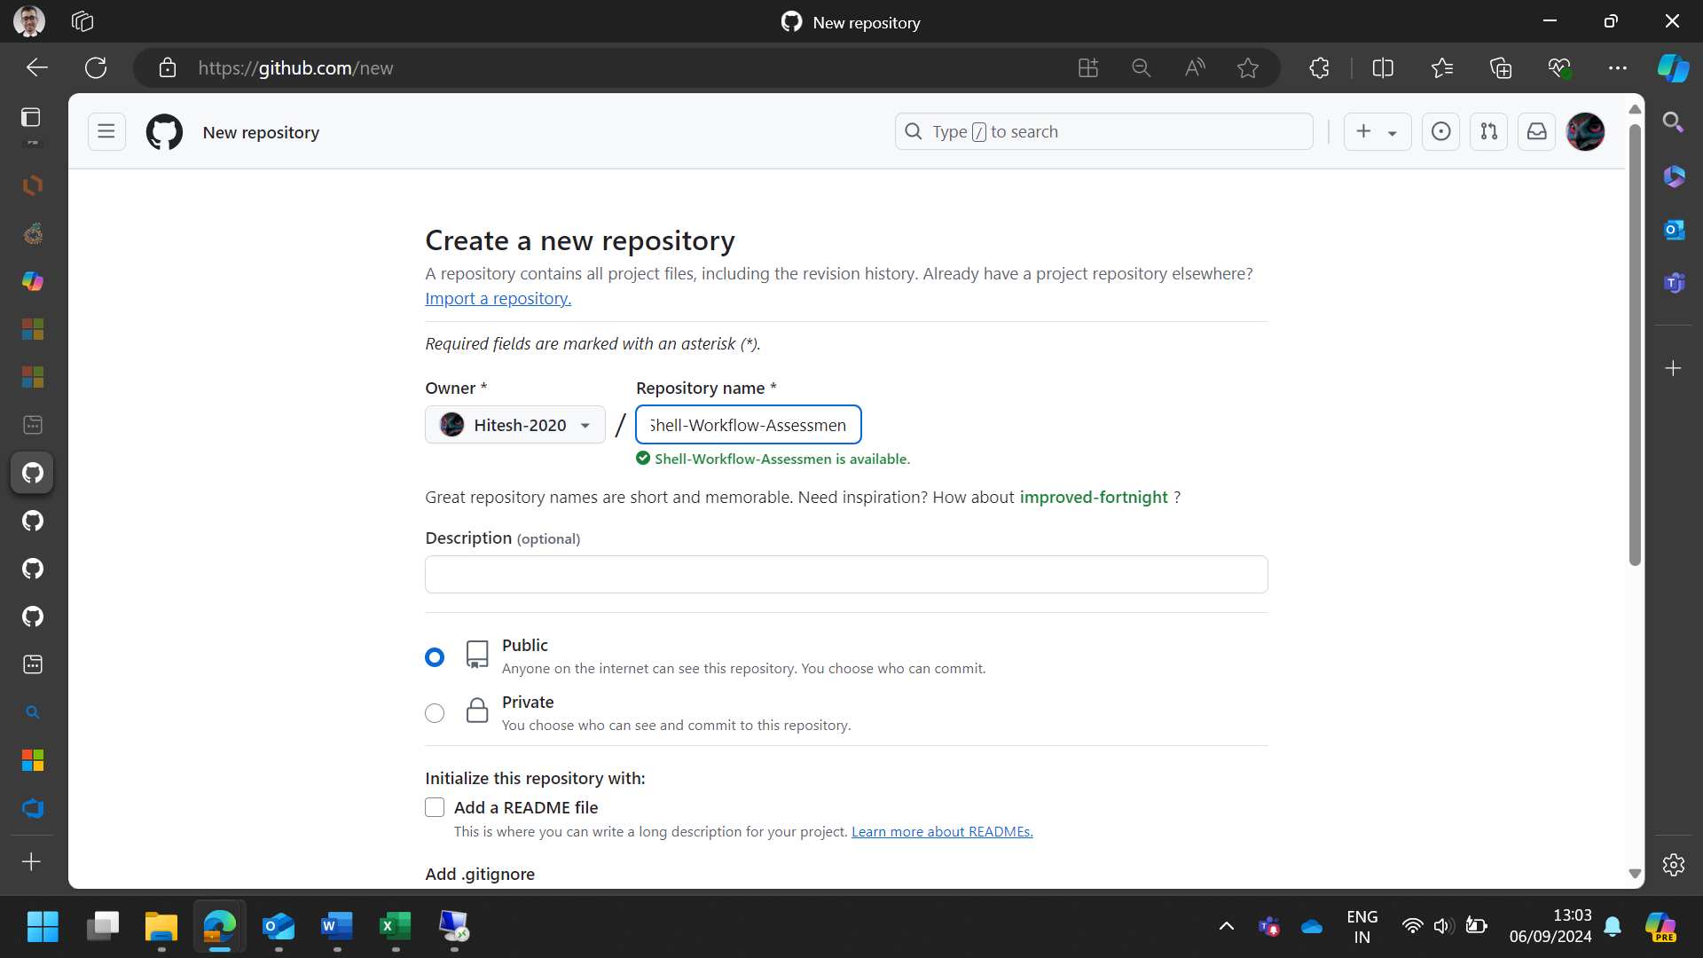

1. Clone the code base of the Java (any preferred language) project into your repository. The project’s codebase would be present in the VM.

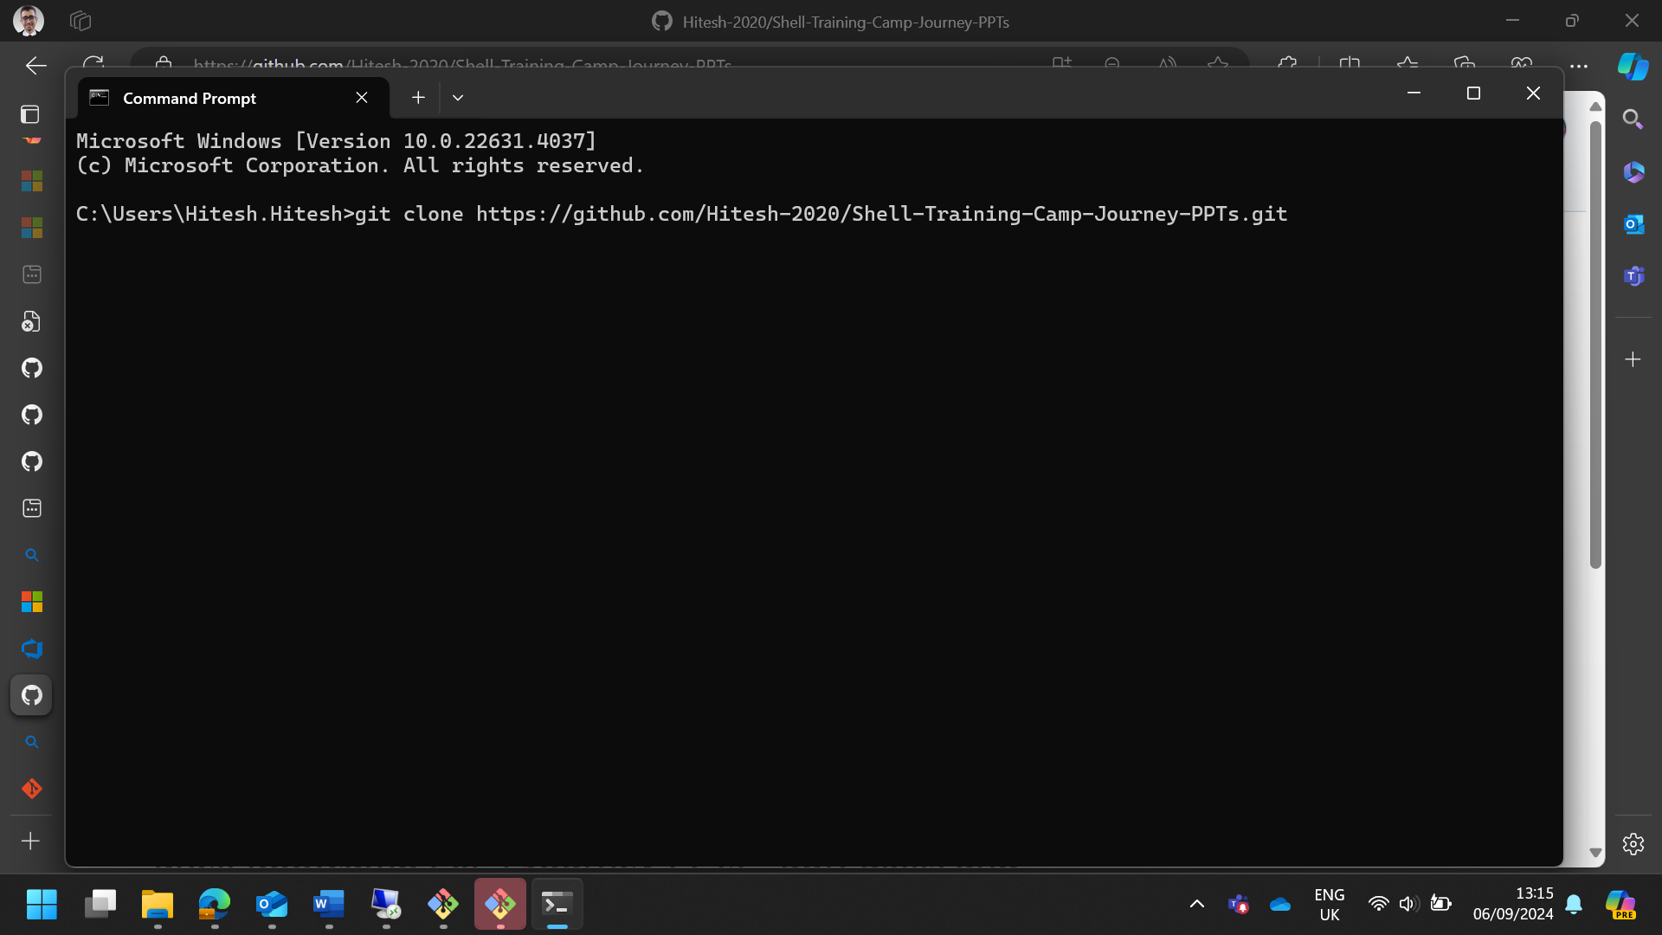

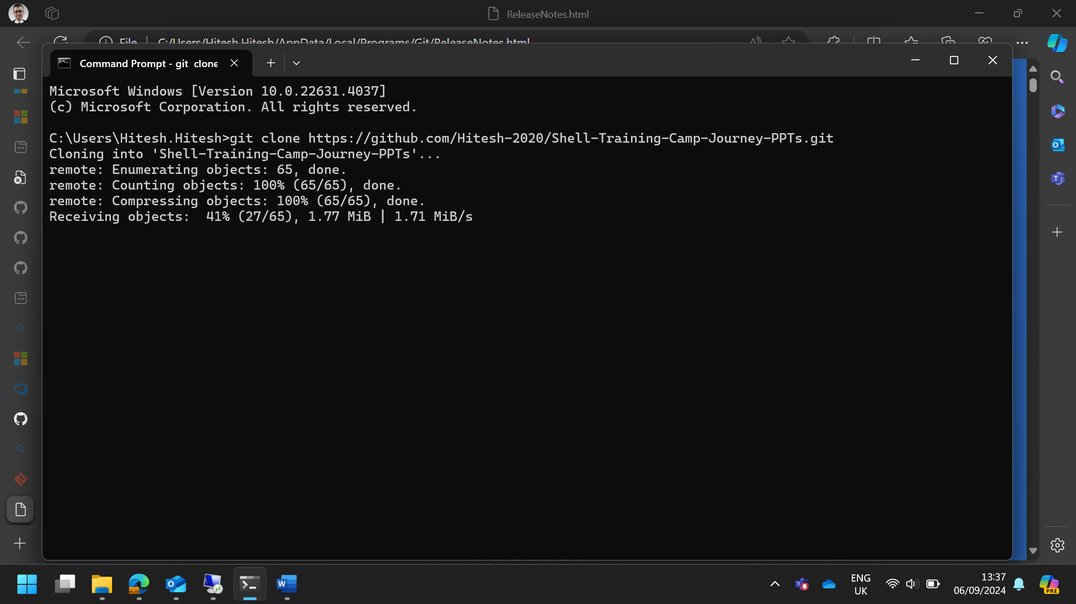

1. Create a New Workflow on GitHub Actions for the Java/Maven code.

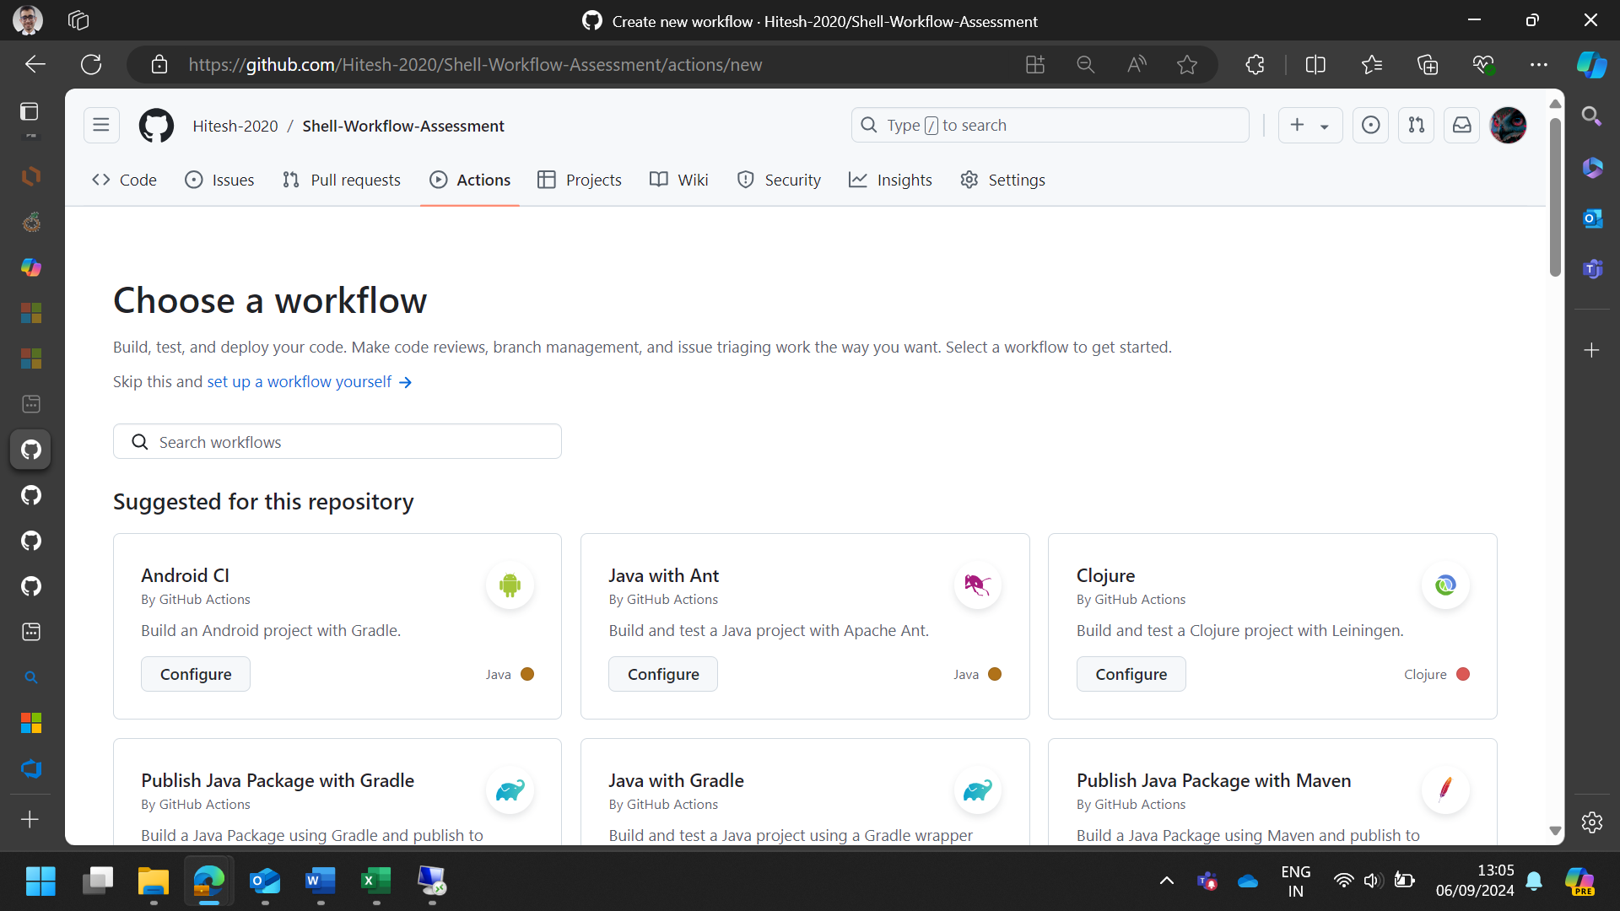

The code script for main.yml

|  |
| --- |
| name: Java CI with Maven  on: [push, pull_request]  jobs:  build:  runs-on: ubuntu-latest  steps:  - name: Checkout repository  uses: actions/checkout@v2  - name: Set up JDK 11  uses: actions/setup-java@v2  with:  java-version: '11'  distribution: 'adopt'  - name: Cache Maven packages  uses: actions/cache@v2  with:  path: ~/.m2/repository  key: ${{ runner.os }}-maven-${{ hashFiles('**/pom.xml') }}  restore-keys: |  ${{ runner.os }}-maven-  - name: Set up Maven  run: mvn -B -ntp clean install  - name: Run tests  run: mvn test |

1. Monitor the created build.

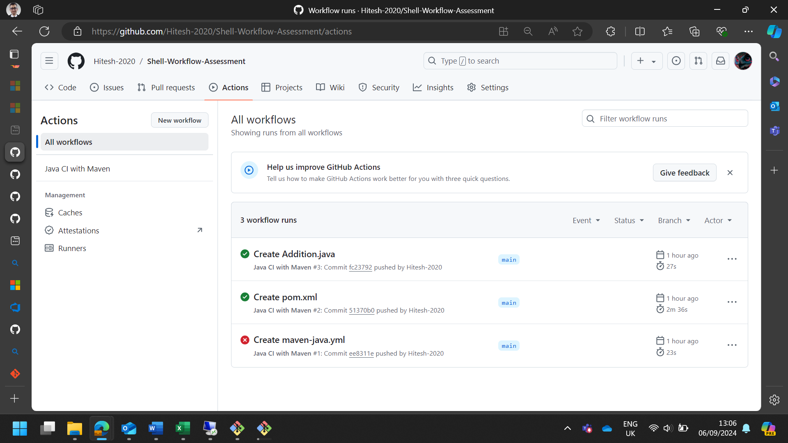

1. Modify the code in your repository to recheck the Workflow and the Build. For example, you could modify a Java class or update the pom.xml file.

Tests:

**Test 1**: Checks the sum of 10 and 20.

**Test 2**: Checks the sum of 5 and 15.

**Test 3**: Checks the sum of -10 and 20.

**Test 4**: Checks the sum of 0 and 0.

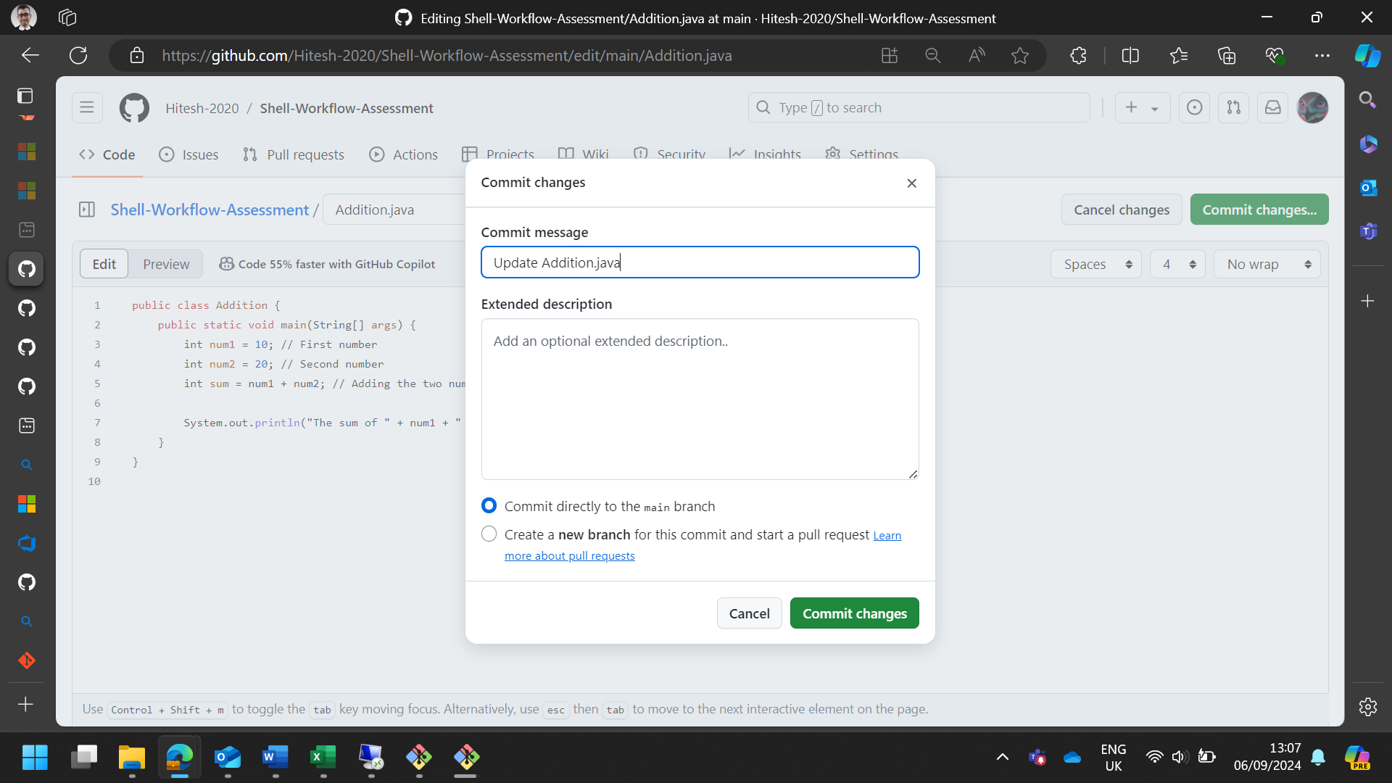

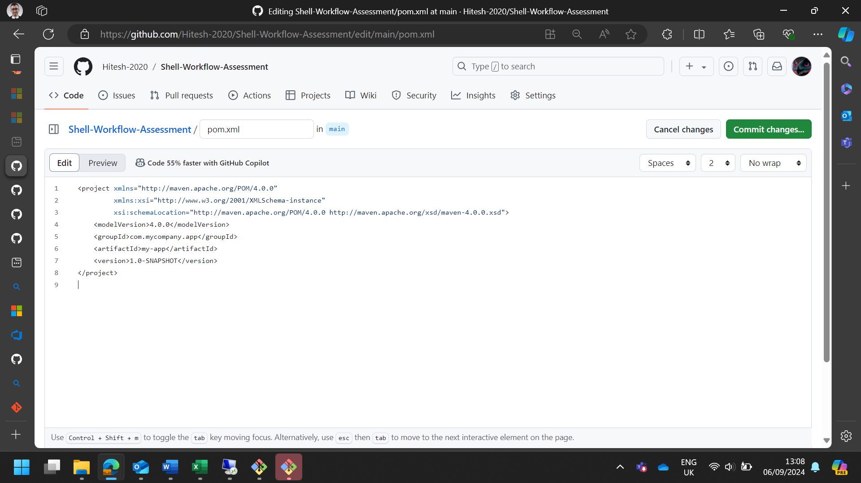

1. Commit it and monitor the build result

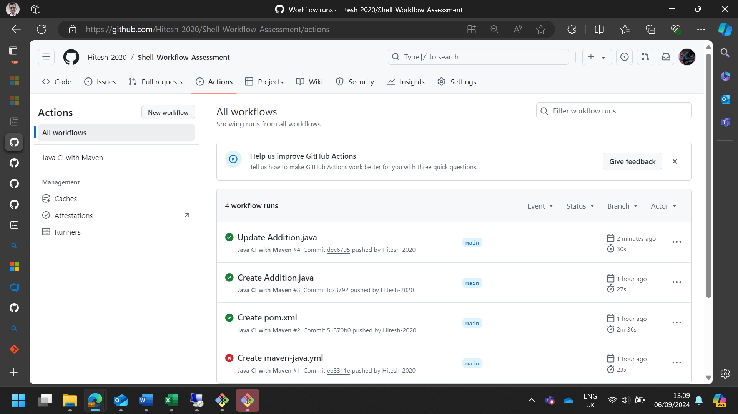

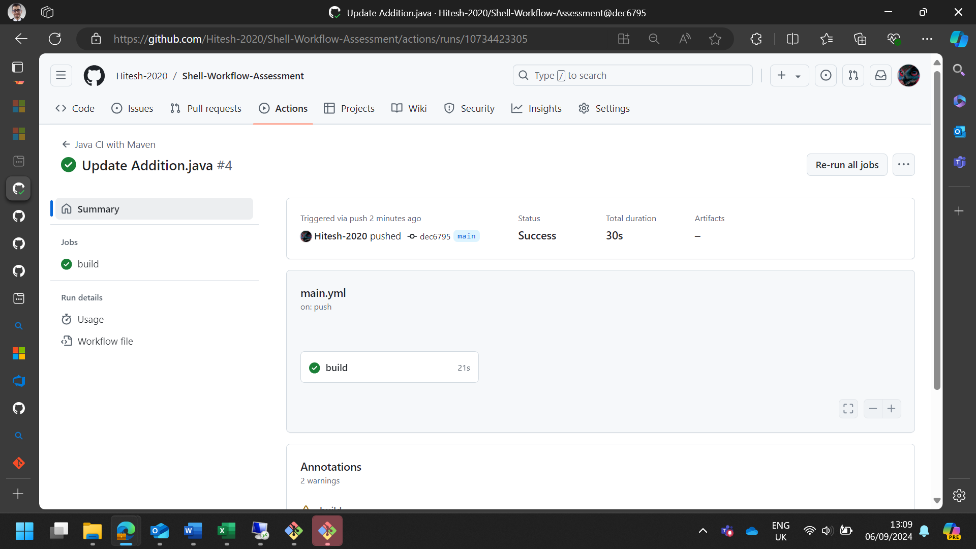

1. Update the screenshot of successful build and commit it in the repo.

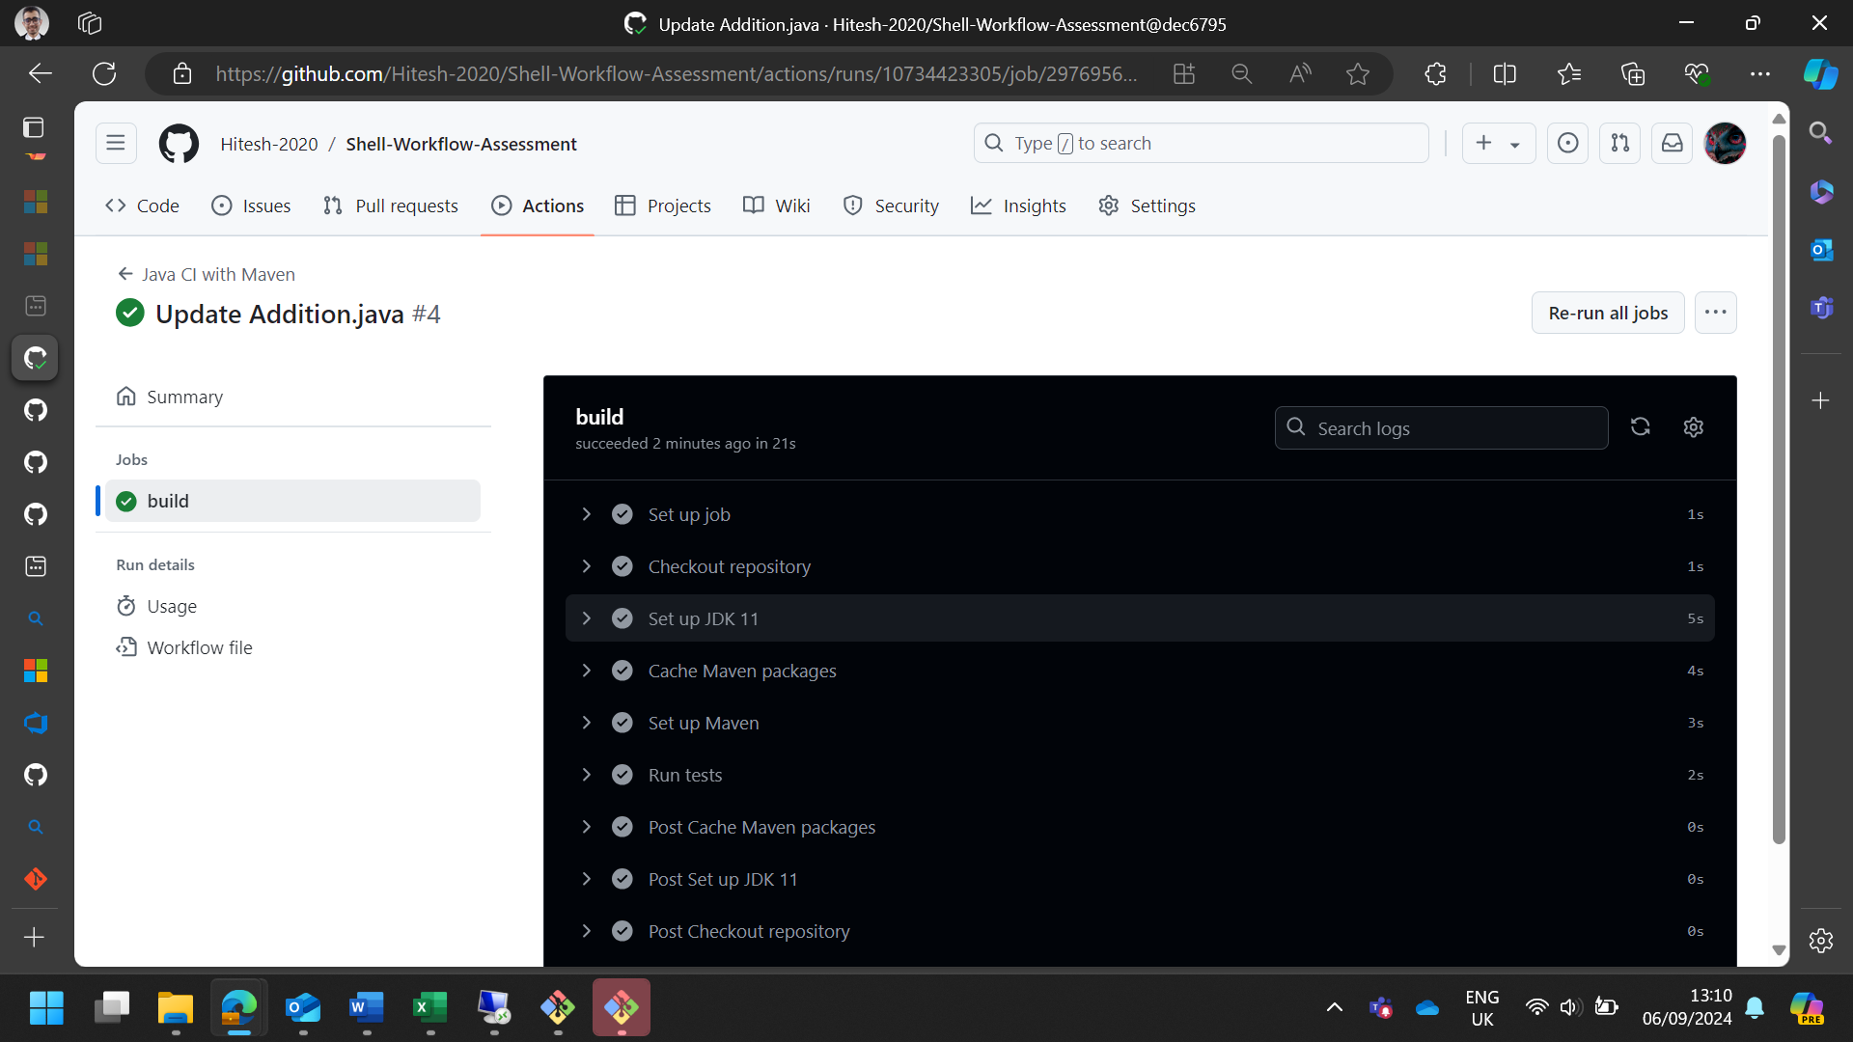

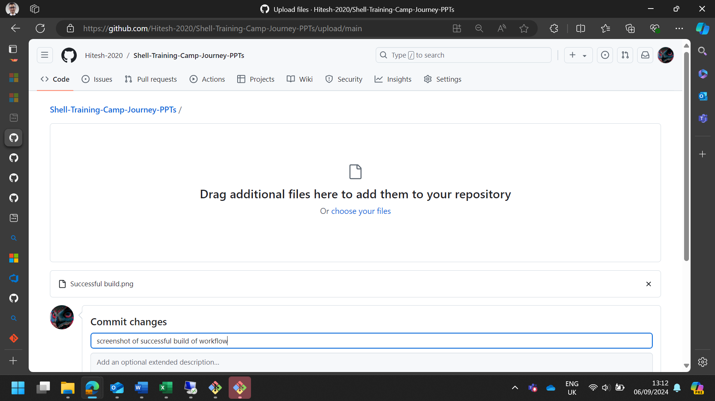

1. In your repository, add the created test cases report and defect report.

